**CMPE 283 notes**

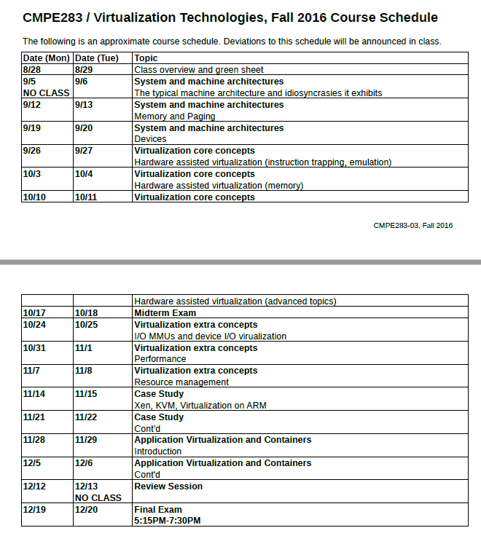

We'll become experts in hypervisors, how they are constructed and how to build them.

Our material changes so fast, and that's why we don't have a textbook.

The Intel SDM is the processor reference manual, 4000 pages. It's not a textbook. Our slides are the main textbook. Use the SDM as a backup. He suggests reading a week ahead, so we can ask questions on the fresh material.

There's almost always a bonus assignment, or other ways to make up points. But he doesn't decide whether to give a quiz until the instant of it, anytime. It'll cover stuff from the previous lecture.

He doesn’t like trick questions. But there's no curve in this class.

His exams are open books and open notes. But not open laptops and not open phones. You can't use it during a test.

For this teacher, the right answer is almost always "it depends."

He failed 35 out of 204 students from all sections of 283 last spring!

He'll try to get us out by 8:15 each night, then 30 minutes after to answer questions.

They'll be a break around 7 pm.

First lecture 9/6/16:

When you are logged into your virtual machine, you “got” your own machine, which you could install VM on, or crash it, or anything you wish.

Why virtualize? Some apps are only used in some OSs, so compatibility is a good reason. Simulation, multiple options, it's cheaper than buying second hardware.

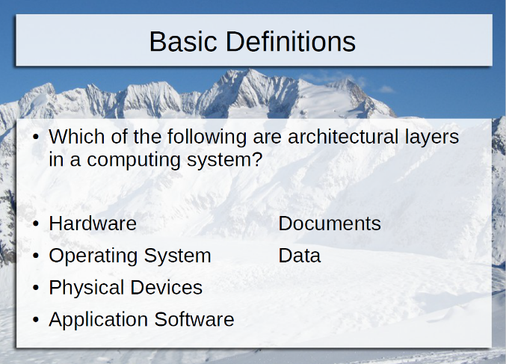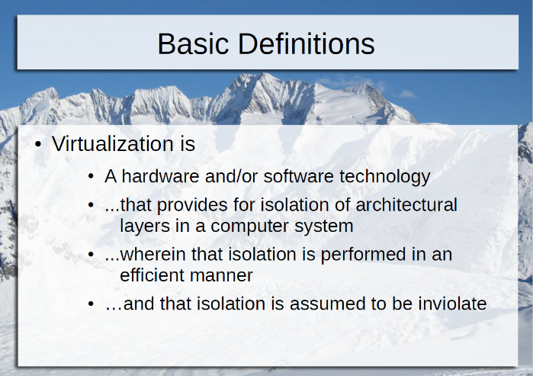The biggest cost is labor.

The Bank of Canada was playing golf with the Bank of England, and came back to his office and said "we need to have virtualization, and we need it all to be on one big server," which subsequently failed. :-) The server needs to be inviolate, which means unbreakable.

Which layers do we want to virtualize?

Any kind of layer could be isolated. A layer is a set of resources with a common purpose.

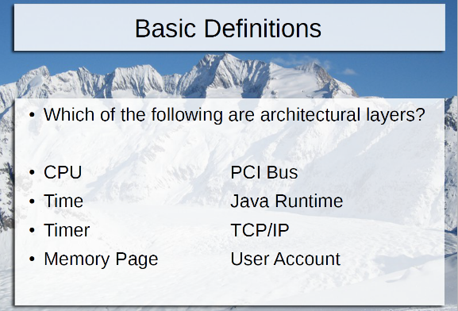Docker offers multiple TCP/IPs, and so TCP/IP could be a layer.

Trying to get time right in a virtual machine is very difficult.

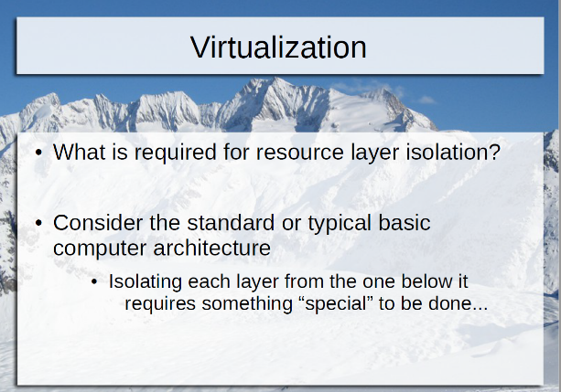AppV, Docker and thinapp, etc. will allow you to run all kinds of apps on an OS. It'll present one copy of the OS to every app, allowing it to be uncoupled.

Profile or User Virtualization would be between Applications and data.

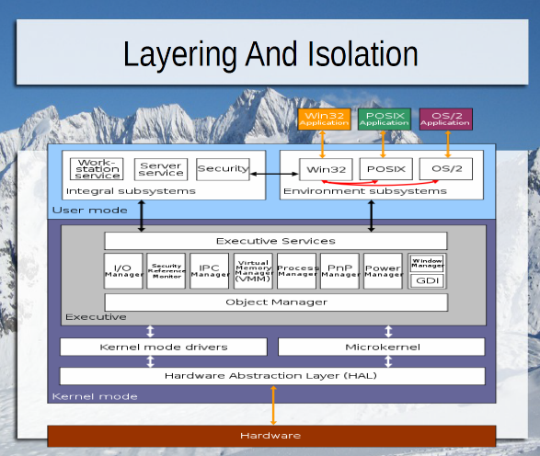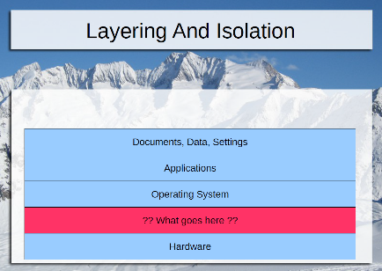Why did Intel not include virtualization in the 8086? Because no one was asking for it back then. We didn't get it until the 386 with the v8086 mode.

Popek and Goldberg's Virtualization paper listed the requirements for a system to be fully virtualizable in mathematical terms.

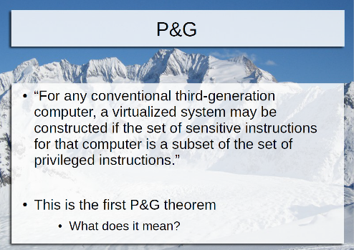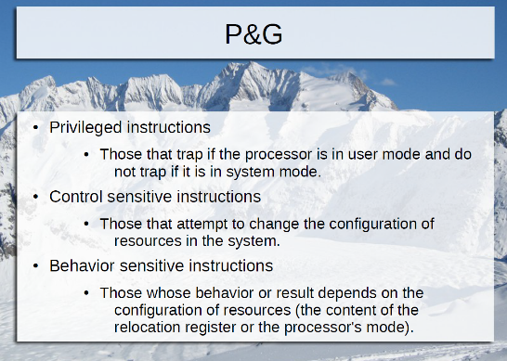Privileged, control sensitive and behavior sensitive instructions.

Privilege can only be executed by the lowest level of the OS. This includes memory management. We'll become experts in that. :-)

Also prefetch cache, flush cache, interrupts, etc.

If he tried to put in a disable interrupt command, it would compile, but it would trap, since the processor is in user mode. Trap means to exit to the higher level of privilege, meaning exit to the OS, which would kill the app.

Control sensitive instructions attempt to change the configuration of resources.

Behavior sensitive instructions, which depend on the configuration. The same instruction behaves differently if you are in a different configuration.

Cisc means each instruction does a lot of work. It has more than Risc.

The sum of control sensitive and behavior sensitive must be a subset of the privileged instructions. Everything that's sensitive must trap and the OS will stop it.

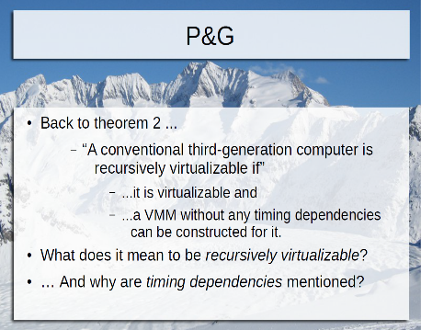If this is met, you can put another VM inside it if no timing dependencies can be constructed for it. If there's no way for an inner VM to determine that it's really a VM. That's VM fidelity. Make them think they're running on a real machine all their own.

In the big SDM document, it'll tell you how long each instruction is supposed to take. If it takes longer, then you're probably a VM. That means that VM fidelity is broken, and it could determine whether it's a VM.

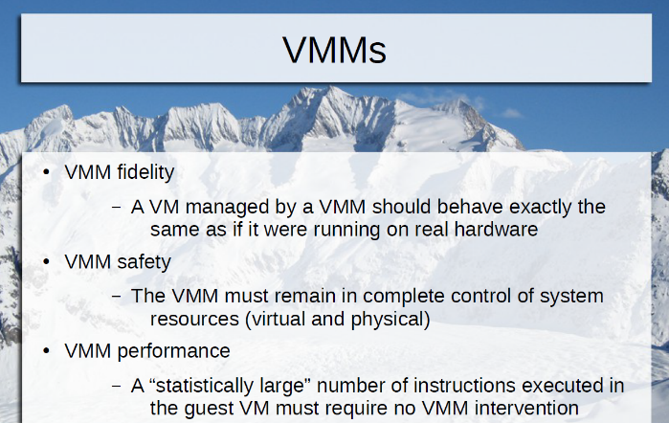But you could fake the VM and give it an unreal number of clock cycles that have gone by.

(Nowadays, it's better to know that you are a VM, because you can cut away some of the baggage and talk to the hypervisor directly.)

VM performance means it should perform fast, just like a regular machine.

If there's one instruction that is sensitive but not privileged, that would be a hole where an app could reach the operating system (and doesn't trap).

The original 8086 was not virtualizable, and we can still run all the old software on these machines. How then are we virtualizable now?

They figured out how to hack around the problem in the 90s. In 2005, they added a new mode to the processor that is now virtualizable, moving all those instructions into the privileged group.

Being backwardly compatible is a weight attached to your leg.

Intel took the virtualization instructions from another processor and added them to this one!

Their academic paper is only eight pages long.

The Intel document number for the SDM is 325462. Search for that number. The newest one is April 2016.

It's easiest to look at the PDF that combines all the documents. Read volume 1, chapters 2.1, 3 and 5 and volume 3, chapter 2.

How could I find an instruction that is sensitive and not privileged? Anywhere between 18 and 22 fit this description, depending if the MOVs are counted as one or not. All it takes is one to keep you from being fully virtualizable.

POPF says take the top of the stack and put it in the flags register. This controls processor behavior. This should trap. Instead, it only sets the flags that you are allowed to set and leaves the others unchanged. But this is not the flag configuration that you, as a developer, want.

Another is SMSW, which is the opposite of POPF. Read the current info on how the CPU is operating and store it into memory. It's only looking at the info, but it will only reveal some of the info, the part you are allowed to see.

Hypervisors want to interrupt these. In older CPUs, there's no way to interrupt them.

Now, turn on a mode that will make this be a trapping sensitive instruction.

Lecture 2, 9/13/16:

Virtualization is a separation of layers, to make it more efficient for higher-up layers. The main four layers are Data, apps, Operating System and Hardware.

The industry standard x86 architecture hasn’t changed since 1985. Intel actually tried a new process called Itanium in the mid-90s. It was a radical redesign and wasn’t as performant in compatibility mode as our chips. So, it didn’t sell.

The 286 was the first chip to run memory protection, so processes couldn’t clobber each other in memory. 386 added paging, so the OS could present a new page of memory to each process.

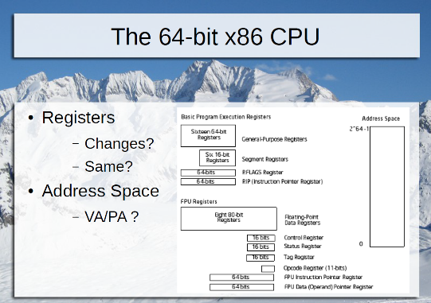GP registers are General Purpose Registers, which can hold anything. FP means Floating Point registers. Eight GP registers is not a lot. RISC chips may have hundreds of registers! Eight for CISC chips is a low constraint. Therefore, it does a lot of memory accessing to make up for this.

There are areas of physical memory that are reserved for devices. They have to be addressable by the OS. These include hard drive, NIC, video, keyboard (which actually doesn’t use a lot of memory). The biggest device consumer of memory is a graphics card, consuming 512 Megs, which is 1/8th of the total 4 gig physical memory in a 32-bit machine! (Of course, the actual card you plug in will have extra memory on it also, accessed via the 512 Meg window.)

Typically, in a 32-bit machine, a page of memory is 4K. There are 1 Meg 4K-sized pages inside the 4-gig physical memory. 4G / 4K = 1 M. You can add access rights to each page.

A process sees virtual memory, not physical memory. The OS translates from physical memory to virtual memory. Normally, there’s the same amount of virtual memory as physical memory.

64-bit registers are named with an R and 32-bit registers are named with an E.

ECX is usually used for counting and looping.

Segments are rarely used anymore for 64-bit operation. It’s used a lot more in 32-bit and 16-bit OS. It allows you to set permissions on 1meg segments. When you create a hypervisor, you have to simulate the segment operations.

With a 64-bit machine, you get more general purpose registers, adding R8, r9, r10, r11, r12, r13, r14 and r15.

With a 64-bit machine, you can theoretically address 2^64 in physical addressing, but no machine can be made that has that much memory! No one could afford that and it would be huge. So, currently we’re at 2^48, which is 2^ 8 terabytes. A new one is coming out that is 2^54.

How about virtual addressing? It’s currently at 2^48. If it’s less than physical memory (2^54), then that means a single process can’t access all of memory.

PAE was a bridge that extended 32-bits up to 2^36. But nowadays, might as well go to a 64-bit machine.

We need to simulate all these registers in our hypervisor, including all 32-bit limitations and all the additional registers.

Register to register transfer is the fastest transfer in the CPU, hundreds of gig operations per second.

“AND r/m64, imm32” means ANDing a register that is 64-bits wide, or a memory location that is 64 bits, and an immediate (constant) 32-bit value, and put the result in the first operand.

One of the control registers controls how pages are mapped throughout memory. Another one controls which 32-bit or 64-bit mode you’re running. Another one is debugging, which will follow traps.

MSRs are special purpose unique to a model of CPU. Model Specific Registers. Controls processor behavior, like throttling speed when it gets too hot, which changes if you don’t have a fan, etc.

Real mode refers to 16-bit. It’s the oldest mode available, from the 8088. Limited to 1 Meg of physical memory. It’s used during early system startup.

Protected mode comes from the 286 and 32/64 bit paged mode comes from the 386. Today, we use protected plus paged. This allows adding permissions to each page. 32-bit paged mode is the same as 64-bit paged mode, but 64-bit mode can address more pages.

You can tell you’re a VM by trying to put the processor in a rarely-used mode, and it doesn’t work! ☺

You can cut corners as a hypervisor writer. But it might not sell as well.

A hypervisor called Parallels is interesting. VMWare’s product didn’t do all the oldest stuff correctly. No one used OS/2 except banks. Most ATM machines ran OS/2. But you can’t find modern hardware that runs OS/2 anymore. Parallels made a hypervisor for OS/2, since VMWare couldn’t do it correctly. (They didn’t have VM fidelity for OS/2.)

What’s the first thing that happens when power is applied to the CPU for the first time? Before BIOS and everything else. It starts in real mode. Why? Because it’s hard to get back to real mode once you are in a more advanced mode.

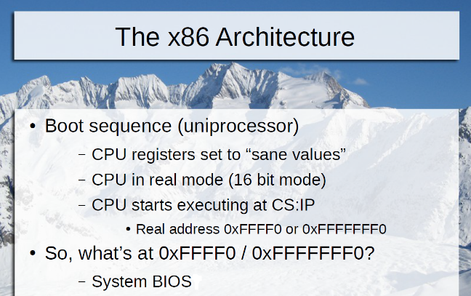Where does it start executing? Not zero. It’s a special address called FFFF0 (actually F000:FFF0). In decimal, which is 1048560. This is slightly less than 1 Meg (FFFFF), the limit of real mode. 1 Meg is 20 bits. You can operate on 16 bits at a time, but the memory is 20 bits.

BIOS is at FFFF0.

Bochs is a simulator that simulates step-by-step assembler. It simulates a whole machine. It’s very good for OS development, although it’s slow.

Bochs showed us that the instruction at FFFF0 is jmpf 0xf000:e05b.

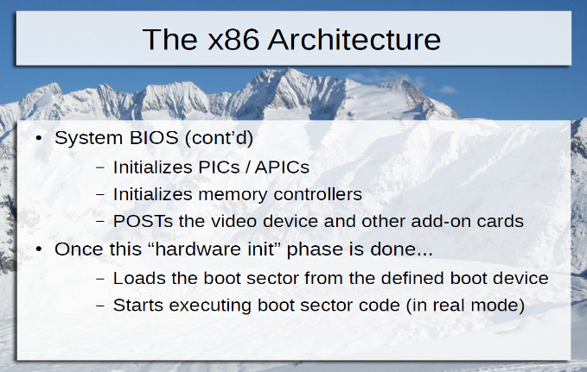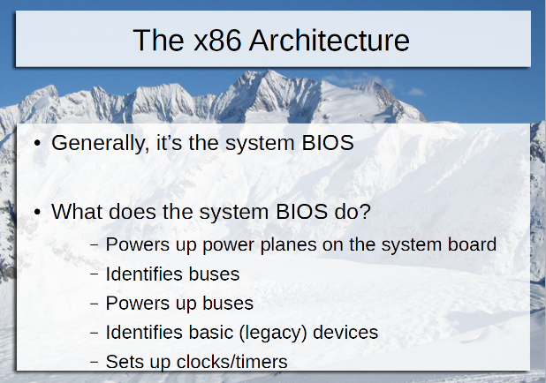Real mode = not paged and not protected. So, the control register CR0 is set to 0x6000010 to be in real mode. Page 2279 in the manual tells all the startup values for all the registers.

BIOS powers up the memory controller, then other parts of the CPU. Then performs a memory check.

Then buses and then see what devices are there.

Then, the first device it’ll look for is a floppy drive controller. Nowadays, it’s emulated. Next is the keyboard controller, which maps the keys A to 01001011. How many events are generated to the OS when a key is pressed? Key down, key up and the letter itself. If it’s set for repeat, it might be a bunch of events. You can output a command to a keyboard and tell it to turn lights on and change its key mappings.

How many timers are there in a machine? The initial timer is for generating interrupts. Then, a real-time clock stores the time of day. It has its own timer that counts up.

Many Oss set up a 100Hz clock. It generates an interrupt 100 times a second. The OS uses it as the input to a scheduler. It tells the OS to wake up 100 times a second.

His simulated machine in Bochs shows 400 for its clock, because there are four processors on that machine.

After checking hardware, it loads the boot sector from the defined boot device. Every disk has a sector 0. It loads 512 bytes from sector 0. This is the boot sector, which loads a piece of the boot loader, which loads the next piece, etc.

For Linux, the second stage boot loader is grub. For Windows, the second stage boot loader is white letters on a black background asking if you want to use safe mode. Typically, the second stage is 71K. You might be in a more advanced CPU mode here, or might now.

Most Oss have two stages. So, the next thing is you have to load is the OS kernel. The second stage will understand where to find the kernel, loads it and transfers control to it. It might still be running in real mode.

There’s a new style of firmware called UEFI. It’s a replacement for legacy BIOS, removing legacy support. It provides common APIs and execution environment for bootloaders. Should you provide EFI? Not if you want legacy support. Nowadays, most people have EFI. It’s shipping on all new machines, but with a legacy compatibility mode, which will eventually go away.

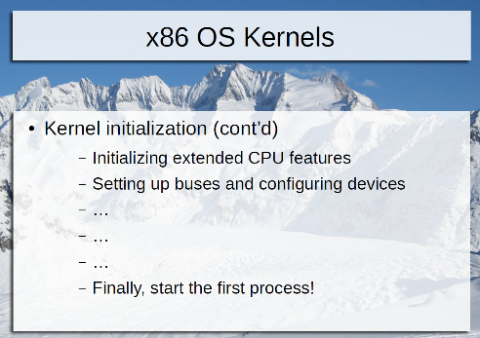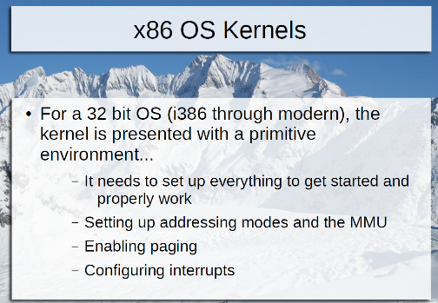Then you need to get out of real mode, turn on interrupts and paging, and the other things on the slides.

The first process starts after the donut of hope (the circling thing) on Windows. For Linux, it’s the moment you see the first thing in color. It runs init, then systemd. Windows’ first process is called Wininit. The first one is responsible for spawning more processes.

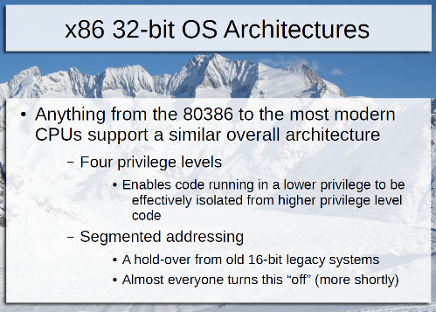There are four privilege levels (rings). Level 0 is the highest privilege level. Most Oss don’t use 1 and 2 for anything. He thinks they’ll cause weird behavior if you do. ☺ OS/2 used them. The kernel and device drivers and interrupts execute in ring 0. Apps run in ring 3.

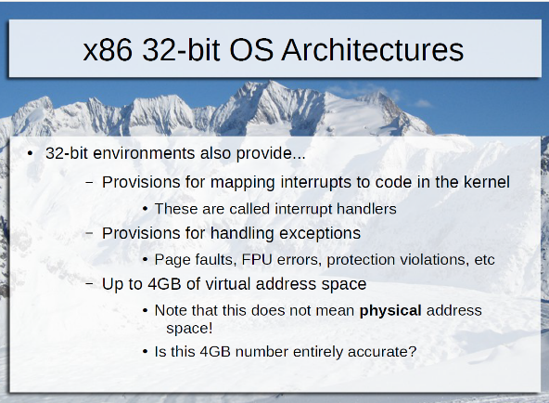Each page in memory can be assigned a certain privilege level. So, this page gets executed in ring 0, for example. Another page runs ring 3. If it tries to jump to a page in ring 0, you’ll get a #GP, which means exception (#) general protection.

Ring 0 code can write to ring 3 page, generally. There’s another attribute of each page called read or write. If it’s set to read-only, then you can’t write to it.

How does our browser get the OS to get a file for it? Call an API system call.

There’s a table called the IDT – Interrupt Descriptor Table. Has a list of locations pointing to places in the 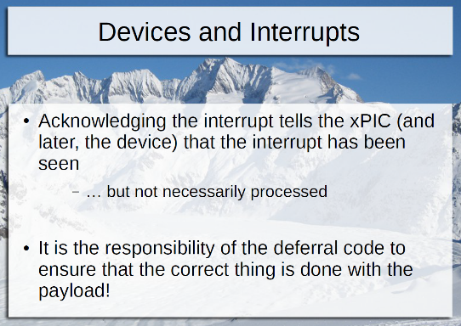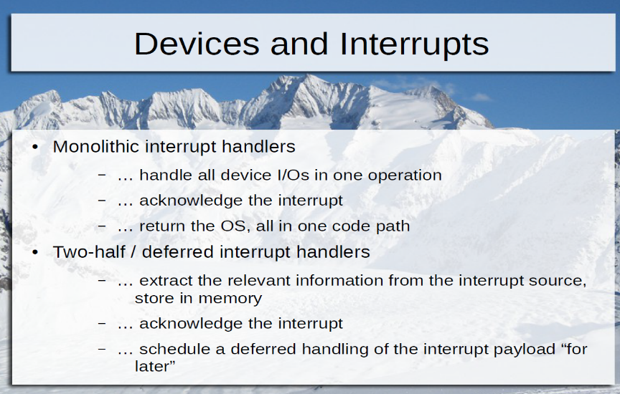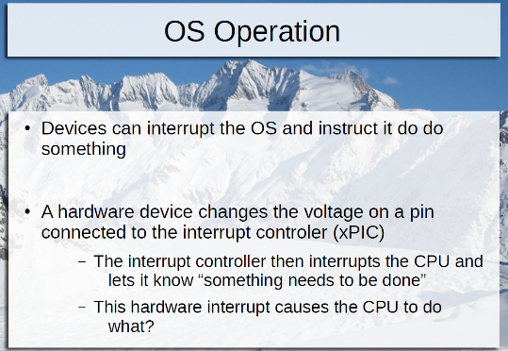kernel. Interrupt 1 might be for the clock. When a clock signal comes, jump to the memory location pointed to by that. The keyboard interrupt is to figure out what key was pressed and send it to the app that’s in focus.

Hard drive storage controller interrupt would be telling the OS that the sector has been read now. The OS can now have the data. It was doing something else in the meantime. Same with the NIC.

What’s the IPI interrupt? Interprocessor interrupt, when a CPU interrupts another one. IPIs are how processors start up other processors.

ACPI0 is the third interrupt on his Bochs simulator, for overheating, connecting to a dock, etc.

IntelDRM0 is video. They accept commands to draw lines, polygons, etc. It’ll tell the OS it’s done drawing it.

XHCI0 is USB 2.0. EHCI0 is the older USB 1.0.

Asalia0 is sound. It tells the OS it’s done playing the sound. It won’t play another sound unless you tell it to. The default is to repeat the sound.

PPB is the PCI bus, which doesn’t generate interrupts.

IWN is wireless. AHCI is the disk controller. PCKBC is the keyboard interrupt. One for the mouse.

He pressed two keys, which generated six interrupts, because a key usually bounces.

The average of his machine is 864 interrupts per second. The four CPUs are pulled away from work that much per second! During an interrupt, the CPU isn’t doing anything, generally. The least amount of time you can spend there, the better.

Volume 3 Chapter 6 has a list of all the exceptions, such as #GP.

If you ran a loop while(1), the CPU would get very hot and the fan would turn on. You don’t want to do that. So, how do you tell the CPU to do nothing?

The processor can turn pieces of itself off when it encounters HLT. Power consumption goes down and it’s cooler. How do you unhalt? With an interrupt. So, interrupts must be on. If they aren’t, the CPU is off forever. The exception is unmaskable interrupts, like IPIs. Those can still interrupt. So, don’t do CLI, then HLT. ☺ Some hypervisors will kill the VM if you do that.

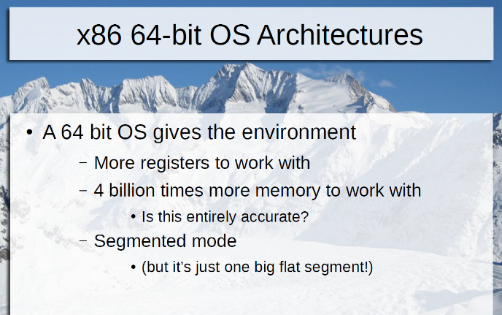So, generally interrupts will trigger the OS. Those are external. There are no internal triggers.

We are on slide 29 of deck 2.

Read volume 3 chapters 6 and 9, but skip 9.2 and 9.11. Chapter 9 tells how you get in and out of real mode. And read the documents in the repo at <https://github.com/0xAX/linux-insides/tree/master/Booting>.

Notes for lecture 3, 9/20:

His assembler has the first parameter as the source and the second as the destination. That’s opposite of what I’ve been taught.

These are all valid:

ADD $0x123, %RAX

ADD %RAX, %RBX

DIV %RCX, %RAX

MOV %RAX, 0x1230

MOV %RAX, %RCX

This is invalid:

MOV *%RAX, 0x892, because it’s too similar to MOV 0x456, 0x892. You can’t move one memory to another directly. It has to go through a register first. * means pointer, getting what it points to. Fix it by changing it to MOV *%RAX, %R8 moving into register R8.

MOV %RAX, $0x1230 is invalid, because $ means a constant number, and you can’t move into a number. Remove the $ and then it’ll be read as a memory location, which is OK.

If there’s no mapping for the page of memory in which 0x1230 resides, you’ll get a page fault exception. If it’s part of a higher privilege memory, then you’ll get that exception.

How big is the virtual address space if you are operating in 32-bit mode? 2^32, which is 4 gigs.

For each virtual address, there’s a range of physical addresses it might correspond to. In page mode, the processor will change any virtual address to a physical address via a page table. Each process will have its own page table. It’s the operating system’s responsibility to manage translations between virtual and physical addresses, and assign them as needed.

If you run out of pages pointing to physical memory, and a request comes in, you have to pick something and kick it out. You could choose the least used, the oldest, etc. His favorite is to find the one that has been written to the least, so you don’t have to save the contents of it. That’s what Windows does.

If it has been written to, write it to a swap file on disk, and tell process 2 that it’s on disk now. The “used” page can now be zeroed out for the next memory request or remain dirty.

HLT says don’t execute any more instructions until a non-masked interrupt is received. If you do CLI then HLT, it won’t wake up unless you have a hardware fault, which won’t happen on a hypervisor. The KVM hypervisor looks for this sequence and if it’s executing, KVM will terminate your virtual machine.

The interrupt controller determines which interrupts have higher priority than others. It examines this via an IDT table. The kernel has an interrupt handler in it. That handler tells the hardware that the signal has been received. It stores the state of the registers onto the stack, and then handles the interrupt, then it restores the registers back (as part of the IRET).

An example of an interrupt is when the disk is done reading four sectors and put them into the disk buffer, and interrupt the OS when it’s done.

A software interrupt is a system call, with the INT command. Windows used $0x80 to point to where the interrupt table is. Unix’s table is at $0x2e. But INT isn’t used anymore. Now it’s SYSCALL or SYSENTER (same as SYSCALL with a different number of bits).

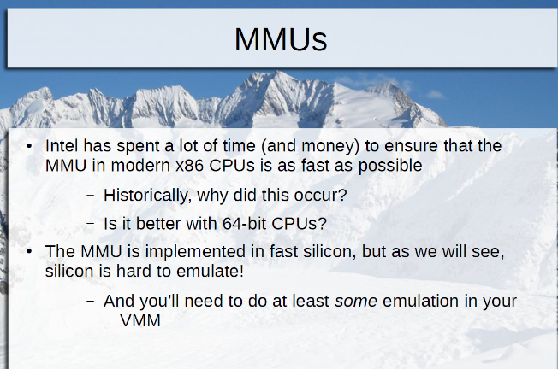The MMU Memory Management Unit gets involved in everything. It’s responsible for page translation.

MOV $0x1234, %RAX shouldn’t access memory, since it’s just moving a constant into a register. But, the assembler code itself is stored in memory. Let’s say this instruction is at 0x10000h. So, there’s one trip to read in line 0x10000h. This is a virtual address.

Everything in this class uses virtual memory. So, there’s another trip to traverse the page translation table. And that’s time-consuming, as many as five lookups. Then, you update the table and said you accessed it. So, that’s the seventh trip to memory. He knew of a case that took 261 trips to memory! And the MMU is always involved with every trip to memory!

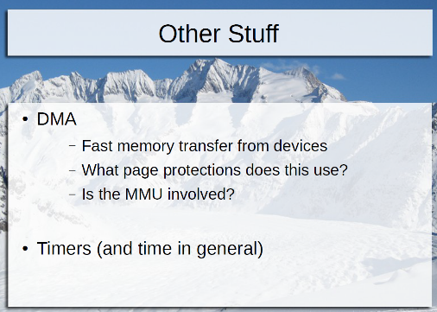There are eight registers in 32-bit mode, instead of 16 in 64-bit mode.

You’ll have to emulate the MMU in your hypervisor! Wow! This will take a lot of lecture time in the class.

There’s no translation when the NIC controller writes to its buffer in memory, since it’s directly physical. But you need something to keep you from writing over other processes pages. So you get your own memory management table.

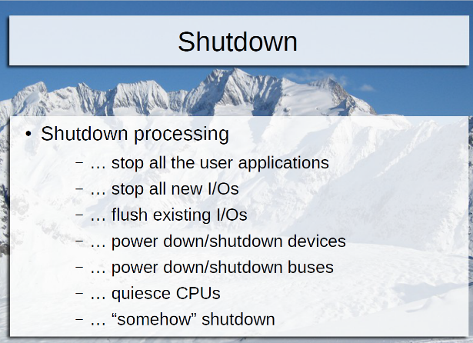How does the machine shut down?

The processor is connected to the embedded controller, which controls the power supply. So halt –p will turn it off. You don’t want your virtual machine to interact with the real embedded controller. Just tell the machine to terminate your virtual machine.

Sometimes a process needs a clock cycle to end before it can be finished.

Now we’re starting slide deck three.

The BIOS configures the memory controller and probes the devices to see where to boot from. But the OS first stage does it again, to get the info about those devices.

There’s no such thing as a multiprocessor BIOS, so it has to be done in the kernel. As long as you sent the IPI to start up the other CPUs after the kernel is loaded, it’s OK.

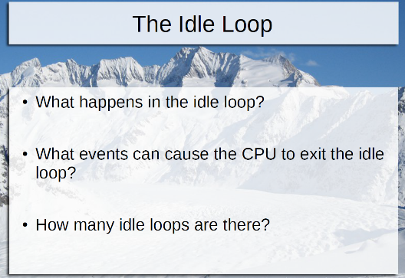Some Oss will enter their OS idle loop before starting the first process, and some won’t.

There are two kinds of interrupts that cause a CPU to exit its idle loop: device interrupts and timer interrupts.

He found the actual code in BSD, called sched_idle. Inside, there’s a while(1) in it. Inside that loop, there’s cpu_idle_enter();

AMD did 64-bit CPUs first, so it’s called amd64, even though our CPUs are made by Intel.

Inside cpu_idle_enter(), it moves a function pointer into RCX, then JMP to it.

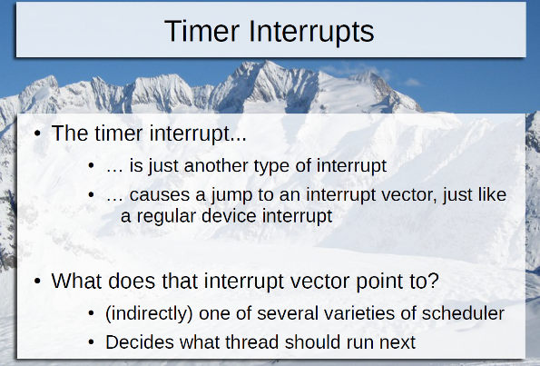Cpu_idle_mwait_cycle() is the new function used by BSD now. It’s used with monitor(). These allow the CPU to go into a deeper form of HLT to save more power. The first thing mwait does is check whether CLI has turned off the interrupts. If so, panic.

How many idle loops are there? There’s one copy of the idle loop code, but each CPU is executing it simultaneously.

Timer interrupts can also interrupt the idle loop. The clock interrupt handler is accessed a LOT, 100 times a second! It’s called hardclock(). It calculates priorities among processes and reorders them. Eventually, it increments ticks and exits. But before it exits, it calls roundrobin(ci), to see which process runs next.

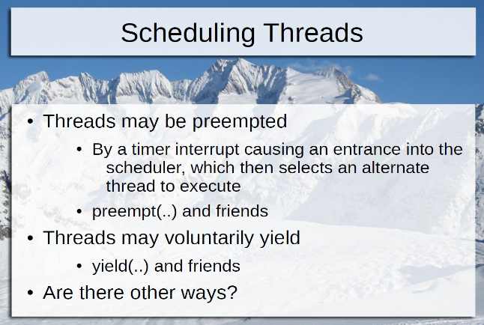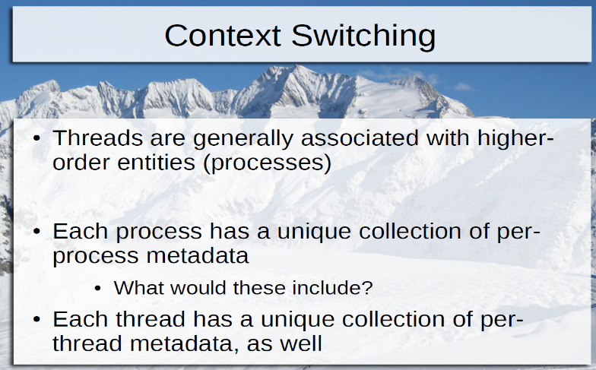Each thread has characteristics (metadata): greediness, size, registers, time used so far, priority, locks, etc. Yield is when you give up your CPU time voluntarily, like when you are waiting for a lock to be released, or you sleep until a timer goes off.

Each process has a process ID and a parent ID, memory map, file descriptors for open files, and name of process, owner, security credentials, current directory, etc.

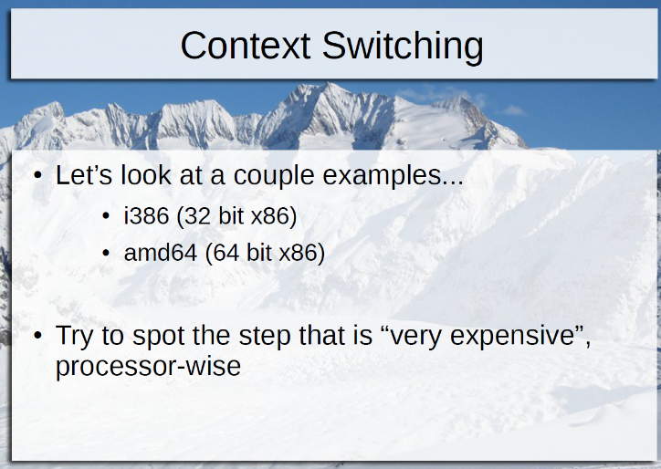To switch to a different thread, call cpu_switchto(old proc, new proc). If the old process still exists, then save old stack pointers, turn off interrupts, get new process info, and do a pmap switch. It is done with register %CR3, control register 3, like so:

MOVQ %rax, %cr3.

Q suffix means 64-bit and L suffix means 32-bit.

CR3 points to the active page table for the active process.

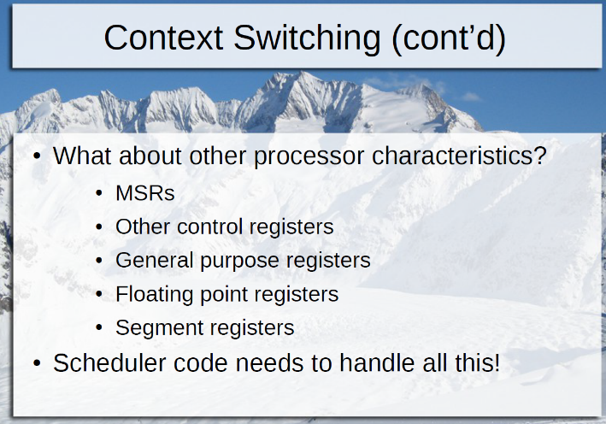Which step is the most expensive? Copying floating-point registers takes time, but touching CR3 is worse because you can no longer use the paging table cache, called the TLB, Translation Lookaside Buffer. It saves a lot of time having to retrieve the paging table each time it needs to lookup memory. It’s on-die cache. This is caused a cache flush.

When you change processes, you have to invalidate the TLB, flush it out. That’s why changing CR3 is expensive. It changes all the time! It can only hold 1000 times 4K, which is 4M, which is a very small amount of the total memory! It should be bigger. There’s only one TLB per CPU, divided up per VM. It’s half as useful if there are two VMs, for instance.

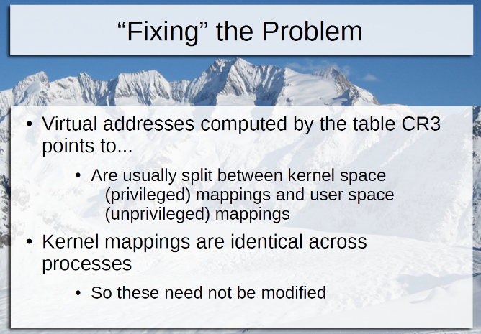Each process accesses the same copy of the kernel in memory. So that entry in the TLB you don’t want to flush. The OS marks the entry as global in the TLB. Those aren’t removed.

Examples of system calls are reading, writing, create, open a file, yield or preempt, exit, allocate memory, open a pipe or a socket, call gates and other traps, etc. There are 330 of them for the BSD. Windows has 4000!

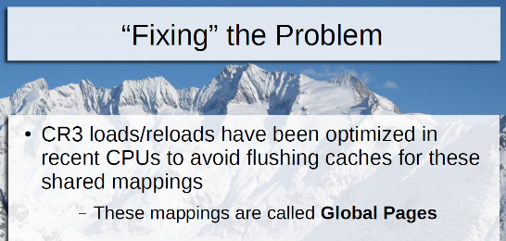One reason Windows has so many is because every graphics operation is a system call in Windows. Every primitive and DirectX, etc.

Syscall is the new way, instead of INT 0x20 or int 0x80 or int 0x2E.

A soft interrupt is a trap to system call dispatcher in the kernel. This is somewhat expensive, in cycle time. You can also do SYSCALL and SYSENTER, which are both much faster.

The hardware interrupt handlers schedule an I/O request on a queue or list, and waits for an answer, unless the caller said not to wait (they want polling or asynchronous I/O). When it’s done, buffers are cleaned up, locks are released and the answer is copied out to the caller’s specified buffer. The system call returns (IRET or SYSRET or SYSEXIT), bringing us back into the non-privileged app.

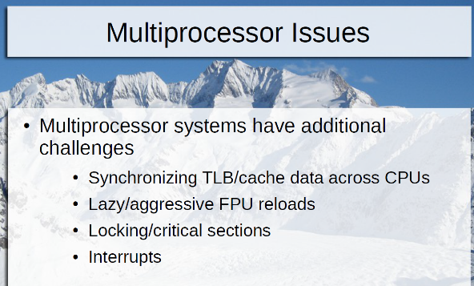You can’t allow a VM to write to the memory the hypervisor is using. So you need to virtualize the memory registers and system buses!

You don’t need to intercede if a VM makes its own interrupts. You care about timers and hardware interrupts.

Read volume 3 chapter 4.

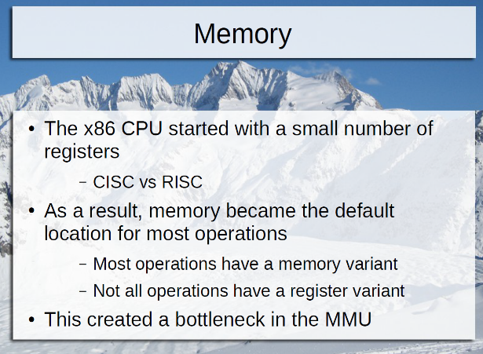

Lecture on 9/27/16:

Now we are on deck 4.

The page table has many levels. Each level of the page table has a piece of the address, plus a pointer to the next page table, which has another piece of the address, and a pointer to the next page table. Eventually, the entire address is gathered, which points to the actual physical memory location.

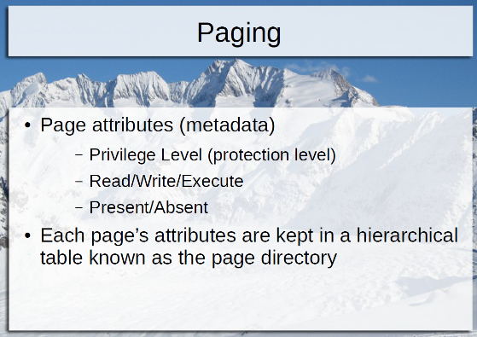These are the page sizes available:

4 kb – most common

2 mb

4 mb

1 GB (only for certain processors and certain modes)

What metadata would the processor keep track of on a per page basis? Why make page sizes bigger? Each page keeps track of whether it’s been accessed, whether it’s dirty, permissions (read, write or execute) and privilege (0 to 3). Privilege level 3 is regular user. Privilege level 0 is the system. Level 3 programs can’t even read level 0. The permissions describe what mode of access you can do if you are at the right privilege level.

If you make the page big, you only need to assign one set of metadata, less overhead.

On his example machine, the kernel size is 10625970. If each page is 4K, you’d have to have 2594 TLB entries. That’s a waste. It’s better to use 4 Meg pages instead, so you could have three entries in the TLB instead. There are separate TLBs for code and data.

If your code is only1/2 Meg in size, and you load a 4meg page, you’ll waste the remaining 3.5 Megs, since it can’t be used. That’s the downside.

Nested paging benefits greatly from the giant pages.

All the metadata (privilege level (protection level), read/write/execute and present/absent) are kept in a hierarchical table known as the page directory.

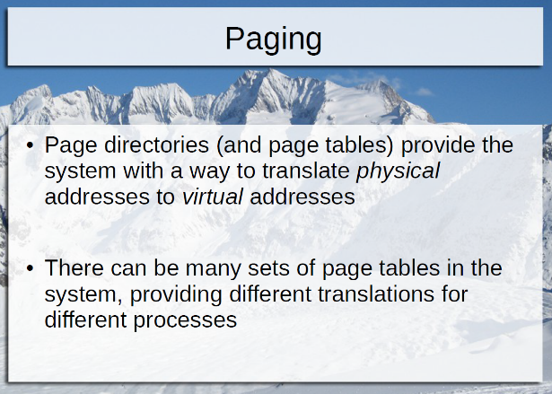Why would have a page table entry that says it’s absent? If you run out of memory, it’s swapped out to the disk and it’ll be absent until it’s retrieved.

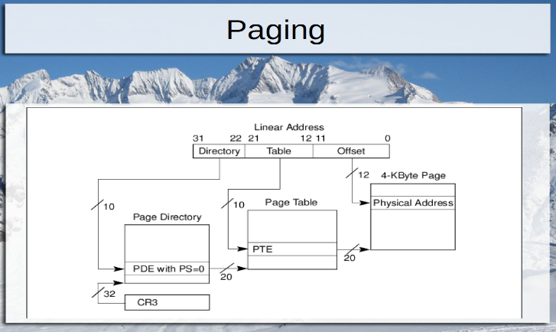CR3 is the register that points to the base of all the paging directory, table and address. The diagram is for a 32-bit machine, showing three different levels of the page table. There’s a 4th level possible for 36-bit physical memory addressing. Page directories in 64-bit systems are 4 levels deep.

How many paging tables can you have present in memory at one time? It’s equal to the number of processes that could be scheduled, perhaps thousands. The number of page tables actually in use is the number of processes that are actually executing.

Paging in a hypervisor is one of the hardest jobs for a hypervisor. It’s difficult to get right on the first try.

The TLB is a fast cache to save walking the page directory so much. When you walk the page table, it’s expensive. The side effect of flushing the TLB is expensive, because you lose all your previous translations.

The privilege level assigned to a page of memory determines what permission code executing in that page has, and what permission is required to access the page.

There’s a new feature that allows you to prevent the kernel from seeing user level 3 pages. Why would you want to do that? To plug a security hole where someone could use the kernel to get to your data. But that’s not common, and won’t be discussed in this class.

JMP may be privileged, depending on where it’s jumping to.

LTR = Load the task register with the value in DX. It’s executed at privilege level 0.

CR3 is Control Register 3. That requires privilege 0 also.

SGDT - put the contents of the Global Descriptor Table register. It stores the location of the segment descriptors. It’s a weird instruction, which is NOT privileged. It describes memory layouts and other things that should not be known by an app. Why is there a need for the app to see that info? Who knows? It was a mistake a long time ago, and because of backward compatibility, it’s still there.

POPF is not privileged, but with it, you can view info you shouldn’t have access to. You can use it to determine what level you are. You should always be privilege level 3. These are the sensitive instructions, but not trappable. They never tell the OS whether they’ve been executed. So, they’re non-virtualizable, because no one knows if the guest virtual machine is executing them. There are 18 more examples! The paper he posted in Canvas explains why they are problematic.

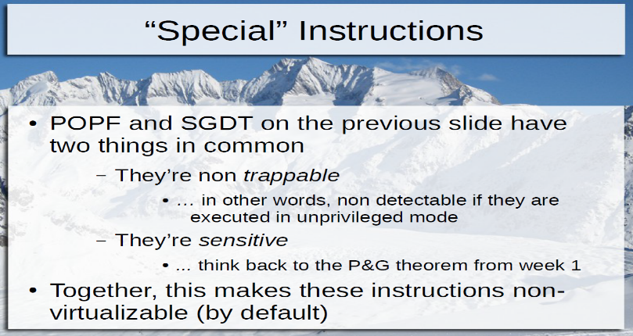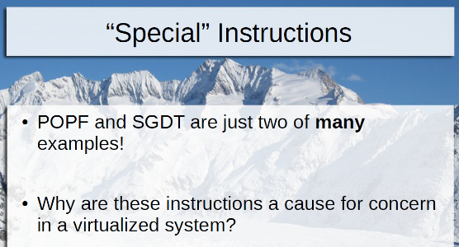

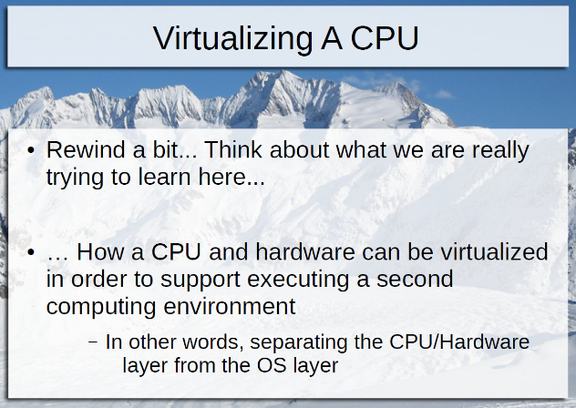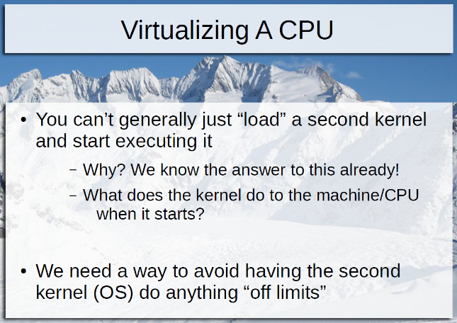

The first thing the kernel does is initialize memory and set up page tables, etc. It thinks it owns all the hardware, etc. So, you can’t have two kernels running. In order to have a hypervisor, isolate the second kernel so it doesn’t do anything that’s off-limits. Don’t allow it to MOV into CR0, which controls the memory map. Don’t allow it to move into any Control Register. No direct input and output to the hardware, etc.

One solution is to load the second kernel as an app, on level 3. You’ll get general protection violations, but that’s OK. Normally, an OS will kill a process that tries to do protected stuff. But we won’t kill it. Instead, we will simulate it and allow it to continue. We are trapping and emulating each one. This is colinux, User Mode Linux, etc.

But what about the 20 strange instructions, like SGDT? SGDT will go unnoticed, and we can’t therefore simulate them. It might return the wrong answer.

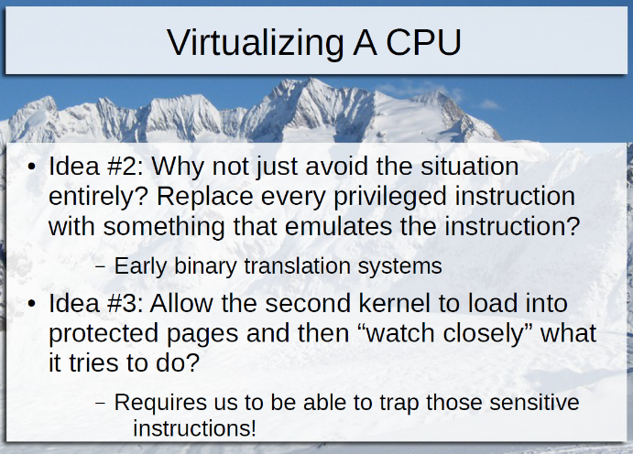Idea 2: Another solution is to look at the code that’s executing in the kernel app and replace SGDT with other instructions that I can intercept. This is binary translation. It looks for a sequence of binary bytes that say SGDT and translate that into something else. This is what VMWare created. This works, but it has other problems. It’s a better solution than the previous solution, though.

The new challenges are handling codes that have been paged out and paged back in and then scan it again, or self-modifying code or code that changes. VMWare did it right and made billions of dollars.

Idea 3 is to put the new kernel back into privilege 0 and watch it.

And there are other ideas.

Classic virtualization means without hardware assistance. With classic, it’s hard to detect something that doesn’t trap when it executes.

Para virtualization removes all the privilege instructions out of the source code. So how does it handle a context switch? It replaces MOV CR3 with a hyper call, a new kind of system call. It’s a call to the 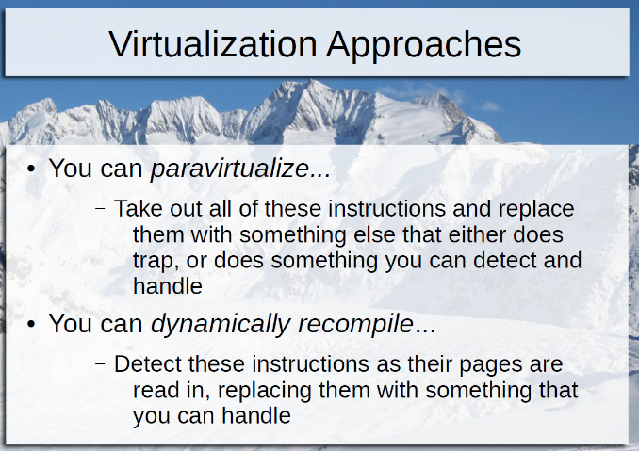hypervisor that does the same thing. You have a library of these hyper calls. Of course, this requires that you have access to the OS source code. So, Para virtualization is something that’s available for Unix and Linux varieties only.

Dynamic recompilation is tricky to get right. It includes self-modifying code, self-generating code and page in/page out.

Or you can let Intel fix it. What does he mean by “letting Intel fix it?” It’s a new mode, called VMX Mode, starting in 2006. It’s a way to do hardware-assisted virtualization.

What has more privilege than level 0? Nothing. Marketing documents say -1, but that doesn’t exist. It’s just a special mode of VMX that allows you to handle certain things. With it, you have more privilege than a guest OS. When there’s a trap, it’ll go to the next lower privilege: 3 to 0, and 0 to -1, to handle it.

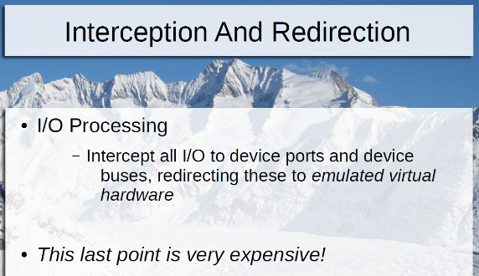VMX Root mode registers its interest in being notified when certain events occur, such as the problematic instructions. VMX Mode is enabled by having VT-X on your CPU.

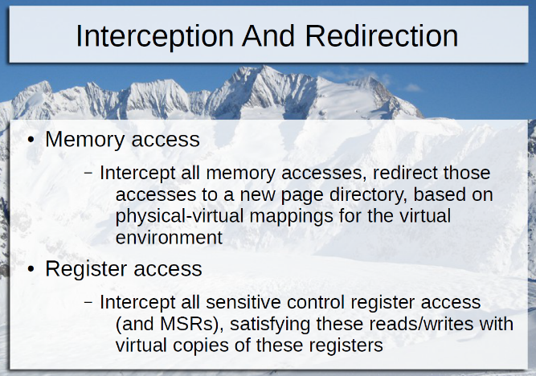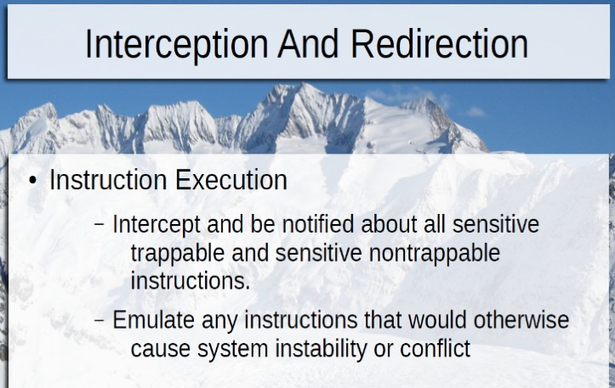

Root mode is the most privileged. Don’t allow the guest machine to execute MOV CR3 or a HLT. What happens if you allow it to execute a HLT? If a virtual machine goes into an idle loop, you want to free the CPU to execute another virtual machine instead. Halt until the hypervisor interrupts it and transition control to it, which allows the CPU to do something else.

The very last thing in the instruction PDF Is the VMX Basic Exit Reasons, when the guest executes HLT, or 60 other instructions, listed in the back of the book.

You can turn on all these flags, and when those conditions happen, control will be transferred to your hypervisor to handle it.

How does the processor know where the page table is? It’s pointed to by CR3. It looks in the TLB first, and then the page table if it’s not in the TLB.

The hypervisor has to interrupt mappings if the memory it points to isn’t owned by that guest OS. What do you do then? Your hypervisor owns all of memory.

And you have to interrupt all writing to page tables, to make sure the guest machine doesn’t read memory outside of its range! So, the hypervisor has to monitor ALL memory access, and all register accesses!

It’s your job to protect the integrity of the system. If that means crashing an OS running as an app, then crash it.

What if the guest OS writes via n OUT to the port controlling the clock? Should we allow it to set the clock?

All OSs write a reset to the keyboard controller, because it’s an old piece of hardware and there’s no way to know whether a keyboard is attached. What do you do when that happens?

All hypervisors do device emulation, telling the guest OS that it has set the clock, when it hasn’t in actuality. Device emulation is very expensive. All time spent as device emulation is time not spend doing something useful with the guest OS apps.

Technically, there are more than 10 reads for the instruction 2000 MOV 0x1000, %rax, for a five level-deep page table. Don’t forget, the “accessed” bit gets set for each level of the page table for each (the 2000 and the 1000)! So, it could be as many as 20 reads. He gave up trying to get the exact number, because it always grows.

Read Volume 3 chapters 23 and 24.

He will post a take-home quiz to Canvas and submit it via email. It’s due next week.

We will be given enough material, including pages from the SDM, when there are quizzes.

Lecture on 10/4/16:

We are now on the VMX / SVM slide deck 6:

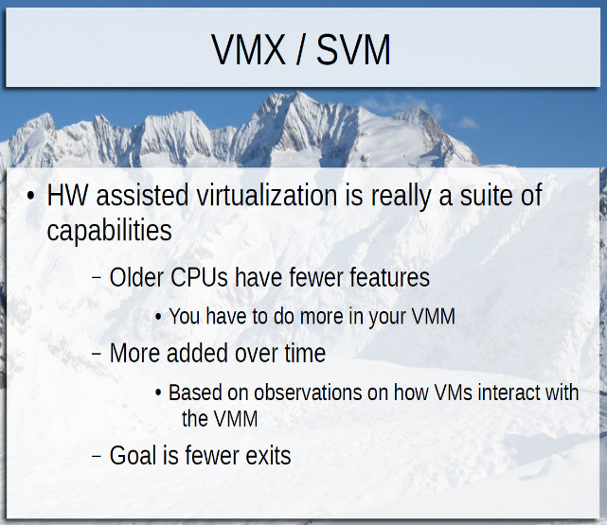Intel and AMD made a new mode called VT-X or VMX mode, which will look for sensitive and not trappable or trappable commands.

What does VMX root mode offer you as an architect? The ability to detect previously nondetectable things, such as privileged instructions when running in ring 0, and detecting sensitive and non-trappable instructions. It allows you to trap otherwise nontrappable things from other folks running in ring 0. VMX root mode provides the virtualization systems architect with the capability to detect previously non-trap label sensitive instructions.

There’s no fast requirement that kernel translations must be global.

When you’re building a hypervisor, the first thing you do is to ask the processor: do you support these 50-60 different features? More features have been added over time.

HLT is a peculiar instruction. What do you do if you are a hypervisor and your Virtual Machine executes HLT and not execute anything until an interrupt comes? Then all your other VMs will also be halted on that processor. This locks a processor. So, VMWare will change all HLTs to transitions to the hypervisor. It’s called a VM guest exit. Then, later you can enter the guest VM and resume execution in it.

What's an example of an exit that you can control? HLT. You can enable exiting to the VM upon a HLT. If it doesn't exit upon a HLT, it could tie on a CPU.

If CPUID is not enabled to exit upon the CPUID command is issued, then you can’t even launch the VM. It’s required to exit when CPUID is issued.

CPUID instruction can be executed by anyone at any time. It’ll tell you its brand and speed and features. The kernel needs to configure itself for the processor that’s running. One attribute is PGE, meaning it supports global pages. HTT is hyperthreading. TM is thermal management. TM2 is improved thermal management. VMX means it supports virtualizations.

Should we let a virtual machine get all this info? No. A guest virtual machine should never be allowed to do thermal management, for example.

Go into the KVM hypervisor in Linux, determine where CPUID is handled, and return your name instead. That was a previous lab assignment for this class. ☺

For example, KVM is the hypervisor built into Linux. If he asked us to look in the KVM to find the virtualization code, go to the virt directory, then kvm, then kvm_main.c. Turns out there’s nothing in there that is Intel-specific. 3000 lines are too small. The hypervisor he wrote is much bigger.

A few years ago, KVM had support for AMD processors. They put part of the code in a place where all CPUs could use it, which is this part. The parts specific to that machine are in a different place, arch/, then x86/, then kvm/vmx.c. This is 11000 lines, which makes more sense. Then it’ll be in its own file: cpuid.c.

CPUID takes input from EAX and outputs it to either EAX, EBX, ECX and/or EDX.

The first thing our method does is read RAX (EAX), and then does CPUID itself, and calculates which values it wants to give to the VM. If EAX is zero, it returns a string in the other registers, four characters each. You could change the returned string. ☺

You wouldn’t be able to find out where it filters out the bits it doesn’t want the VM to see.

And don’t forget to skip to the next instruction at the end of your function.

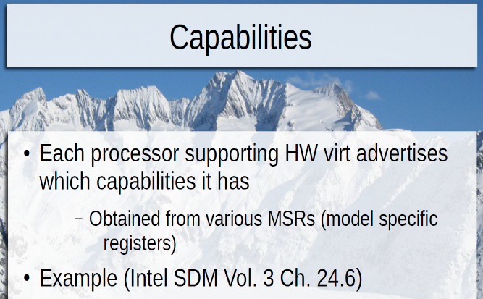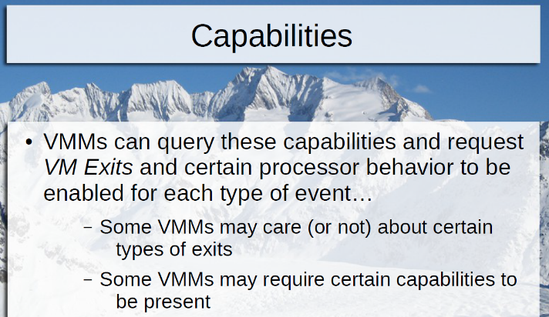

Function 1 returns a long list of features. A VM shouldn’t need to access thermal management, or direct cache access or silicon debug. You AND it with NOT all the bits you aren’t going to pass to the VM.

The first bit (bit 31) will tell you whether you are running inside a hypervisor.

Function 3 is processor serial number, which returns all zeroes.

The set of features your hypervisor reports to the VM is shorter than the original set of features reported by the CPU. It doesn’t support MMS, VMX, TM, HTT, etc. But the brand string can remain the same.

When the CPUID is being handled by the hypervisor, the VMs are waiting, and its performance is being hit. So, you want your response to be fast. And you want to reduce the number of exits and entries. New features have been added to avoid some exits entirely.

Some hypervisors are written for an older CPU spec, meaning they’ll run on any machine after that date. But other hypervisors are written for the most modern CPU, meaning they’ll only run on that, but they’ll be easier to write and have fewer bugs.

MSRs means model specific registers.

Hypervisors can query these capabilities and choose which controls to turn on and off. One example might be whether to take an exit on CPUID or HLT instructions. Another might be an exit when an external interrupt occurs. If this is turned off, it’ll go to the IDT from the guest VM’s OS. But since hypervisors switch OSs every millisecond (for example), the key down will be sent to the first VM and the key up will be sent to the second VM. This will cause an infinite repeat of the key in the first, since it never receives the key up instruction.

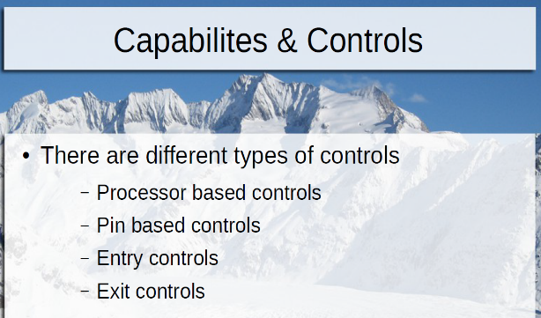Most every hypervisor sends interrupt controls to the hypervisor (by turning this on). This avoids this problem. (Device pass-through is an exception to this.) Interrupts will then stop the VM and send it to the hypervisor.

Capabilities and Controls – four major categories: processor-based, pin-based, entry and exit.

Processor-based will exit on a particular instruction. Pin-based are interrupts (external to the process).

NMI is a nonmaskable interrupt. It hardly ever occurs. It’s reserved for hardware failure or memory corruption, like when a chip is going bad. You want the hypervisor to handle this, obviously.

Processor-based controls are in table 24-6. Every hypervisor turns on the HLT exit, so the hypervisor handles it. You can reschedule the halted VM when a virtual interrupt occurs, to stop its “HLT.”

RDTSC means read the time stamp counter. It starts at 0 and counts how many pulses of the system clock there have been. It’s the most precision clock you have in the system.

There’s no such thing as a write timestamp counter. So, you’ll need to fake the VM into thinking its instructions are taking the normal amount of time.

Do another read timestamp counter every time you do an exit, so you can subtract that time spent in the exit handler, and give the VM an appropriate time interval.

When a guest VM attempts to move or read from CR3, take an exit there. The guest would be able to make its own page table outside the bounds of memory it should have.

RDRAND instruction means give me a random number. The CPU creates a pool of random numbers from the time, heat and other entropies inside the system. Why do you want exits for this? The carry flag indicates whether the number from the pool is available. If you allow unrestricted access to it, a guest VM can put it in a loop, to consume all the random numbers. If you read all of them, you’ll starve the generator, and all the other VMs will not be able to get a random number! Exiting here allows the hypervisor to throttle the requests from the VMs. It’s a single resource, shared among all the VMs.

The exit controls tell the CPU what data you want backed up or restored when there’s an entry or exit. The more is backed up, the less work you as a hypervisor will have to do.

Sample test question: Under what circumstances will a processor wake from HLT? Answer is non-masked interrupt only. Not system call or process context.

A move to CR3 flushes which of the following? Answer: You have one TLB per processor. You also have one CR3 per processor. I think the answer is all non-global translations from the current processor’s TLB.

Which of the following operations does the system BIOS typical perform during startup? Neither configuring paging, determining process scheduling characteristics, booting secondary processors. The BIOS doesn’t configure paging or scheduling processes, and not booting secondary

Sample test question: Which instructions may cause General Protections? Require ring zero? Page faults? Etc.? (Assumption for the question: Assume you’re in ring zero and all the instructions are paged in.)

Since SUB doesn’t require memory, there’s no GP. But pointers use memory, so it could fail if it points to trash or is non-writeable, perms or privileges not set up correctly.

CPUID can run anytime.

Nested paging makes it safe to write to CR3.

You have to turn on VMXON, or else you’d have no VMXs!

How many memory reads does it take to execute a typical instruction? First, we’ll translate where the address is stored. RAX tell you that you are in 64-bit mode. So you’ll have four levels of the page table. After reading each level, mark it as read, which means write to all four levels.

Then read them all again, and dirty each one, and read memloc, etc.

If the paging and MMU structures weren’t in memory, you’d get page faults and many more memory accesses!

Why would you build your hypervisors certain ways? There would be questions like that on the final exam.

There are different type of controls: processor-based controls, pin-based controls, entry controls and exit controls. Processor-based controls are instructions. Pin-based are controls happening outside the processor (interrupts). Entry and exit control the data that is loaded and saved in and out of the VMCS.

VMCS has two parts: Guest state area and host state area, and a little additional info. Register state is stored in these.

Entry step 1 is putting the host registers into the HSA area, and loading the GSA area. Step 2 is upon exit, reversing it. This is a world switch. Use VMREAD and VMWRITE. We don’t store floating-point registers.

Populating the VMCS occurs before the big while loop, as long as live VCPUs or VMCSs exist. Then inside the big while loop, select a machine to execute, then do VMLaunch or resume (same thing). Stop executing each VM on any exit, such as HLT. Then, query to see which exit was done, and do a switch on that. Handle HLT, or CPUID or INT, etc. You must enable between 6 and 61 exits. (The architecture says you must handle 6.) And that’s the whole loop.

The big case statement on exits is the large section of the hypervisor code. When it’s executing, you can’t run any VM, so you want to make it as fast as possible. The I/O statement might take a while, when it’s accessing the disk. That’s the longest. CPUID is the shortest.

Before going back to the VM, handle events, which are pending interrupts. Clock, keyboard, mouse, etc. IPI is Interprocessor interrupt. You should be able to deliver any of these interrupts into the guest OS.

When it wants to play a sound, the operating system puts a piece of sound data in memory and then tells the sound card to play it. Your hypervisor will look at the data, send it to the real sound card, and pass on interrupts from the sound card back to the VM.

If you don’t handle any interrupts, your hypervisor will just sit there.

When would the VMM not want to reenter the VM? It’s on a slide.

When you exit, one instruction that was happening a lot was MOV CR3. If they ignore that statement, a whole category of exits are ignored and performance gets better.

Is there any time when you might not want to increment RIP during the exit? Yes, if it was an INTerrupt. Or perhaps during a HLT (if you want to handle it that way).

CPUID has another side effect. It serializes instruction execution. All modern processors reorder instruction for optimization. But it’s important sometimes for programs to enforce the order of execution. One way is by calling CPUID. So, you must emulate this side effect too.

Entries are easier than exits.

Event injection means you create a virtual interrupt and send them to the guest OS. The guest OS has its own interrupt handler. IDT sends the interrupt there.

If you can get all your CPUs in the CLI / HLT state, then you have no live CPUs, and you can exit. That’s how you shut down.

VMCS has two halves: the Guest VM State Area and the Host State Area. These areas store register state. There’s one VMCS for each virtual CPU in each VM.

The hypervisor is responsible for scheduling which VMCS runs on which CPU, just like choosing which thread to run next. Don’t choose a VMCS if it’s halted, obviously.

Perform an entry on the one you’ve chosen, after loading the registers back in. Each IP tells where to execute next. This is a world switch.

The IP in the host state area points to the exit handler in the hypervisor.

When you start up a VM, the guest state area will start with default values.

The hypervisor can execute VMREAD(guest IP) and put it into a variable, or VMWRITE().

We don’t store floating point state into the VMCS. Floating point registers are much bigger, and there are more of them. That’s a lot of overhead. So, a floating point invalid flag is set, and can be cleared when that VM comes back. If another VM needs the floating point registers, then they’ll be saved as usual. This is lazy FU, done purposely that way.

Hypervisors are two concentric loops. One enters and exits the VM.

VMlaunch and VMResume are the same, for this class. They enter a VM.

Then when you’ve handled the instruction, like CPUID, it’ll return an answer. Write the answers to the registers. Then don’t forget to advance RIP to go beyond the CPUID instruction. But what if the CPUID instruction wasn’t always the same size? In order to read the guests memory, you have to walk through the guest’s page tables.

Nowadays, the exit handler is also presented with the length of the instruction, to advance RIP.

And on the way back, tell the guest there’s a virtual interrupt, so it can handle it. For example, the fake clock ticks and network bytes coming in, etc.

The hypervisor reserves some memory for itself, which holds IPIs.

Executing while(1) with no external interrupts will freeze the VM, so this is why we have clock pulse interrupts from the hypervisor.

The exam will cover up to what we talk about on October 11. Next lecture (10/11) will be the review session.

The midterm will not cover paravirtualization slides, nor shadow paging nor the nested paging deck.

Don't bring your laptop next Tuesday. If he sees it, you'll get an F. You can bring any printed material you want, though.

The midterm is in two weeks. It’s a two-question take-home test, covering the lectures.

After the midterm, there are only two hardware-style software discussions left: memory and device virtualization.

You can google the answers for this quiz, but cite your sources.

Quiz that we’ll need to do before midnight Friday night. Email takes time. If it’s not in his inbox by midnight, it’ll get a zero. Submit many times. He will always sort the email and keep the last one.

1. Why is RDTSC an important instruction to virtualize? What could be the side effects if it was not virtualized? There are a couple wrong answers out there.
2. Is it possible for one CPU to be operating in VMX mode (root or nonroot) and another (or other) CPUs to be executing in legacy (non-VMX mode)? Explain.

Double-check these questions, to make sure they are correct.

Sample midterm, which is right out of the slides. It’s OK to bring them to the exam.

1. Prior to the introduction of Intel VMX, it was not possible to fully virtualize a guest OS on the x86 platform. True or false? Prior to hardware-assisted virtualization in 2006, could you run a VM on this machine unmodified? True. VMWARE did it in 1997 by changing code as it was being executed, binary translation!
2. Which of the following is a feature provided by a VMM? Schedules VCPUs on PCPUs. The guest OS schedules processes on CPUs and handles system calls from processes.
3. Which of the following terms describes a possible treatment of floating point registers during a process context switch? Is this done on an operating system or an OS? An OS. Lazy switch. FP register are very large, so if you can leave them until they are needed.
4. Which of the following best describes the size of the virtual address space on 32-bit Intel CPUs? The virtual space is always 32. The physical space is sometimes bigger than 32.
5. When operating in 64-bit long mode, the depth of the processor’s paging structures (page directory / page table) is 4 levels deep. 32 is usually 3 levels deep, but it depends on your physical size instead.
6. True or false: A legacy system BIOS is typically responsible for selecting a boot device from amongst the available boot devices (perhaps with input from the end user). True
7. T/F The x86 architecture provides for four privilege levels of operation. True
8. Which of the following contains mappings between interrupt vector numbers and interrupt handler routines? IDT. GDT is for offsets, and SDT doesn’t exist.
9. Which of the following will occur if exit on HLT is disabled and a guest OS executes it? The VCPU will become unresponsive until a virtual interrupt is delivered (by injecting an NMI). And the Physical CPU will become unresponsive until a physical interrupt is delivered, and the hypervisor will be unable to schedule other VCPUs on the PCPU that is halted.
10. Which world switch consumes more CPU processing time during register reads and writes to and from the VMCS? VM Entry and VM Exit. Entries store host state into the host state area, but exit does twice as much, because it stores off and loads the other state area.
11. What considerations should the hypervisor author make when determining which VMX controls to enable? A half a page = two paragraphs. Give him an example. He wants that. For example, you must enable the required 6 controls, such as CPUID. Then will you enable the high performance controls or a smaller number? You could say you wanted to enable the oldest compatible ones, to run on all processors, such as ___________. Or you could say you want high performance, the latest ones, such as nested paging.
12. Describe the processor and VMM’s behavior when a guest VM executes CPUID. CPUID is a must exit condition, and in the main loop, extract which exit occurred. Then, look for EAX and see which function was called. If it’s 0, return a string. If it’s another one, do a real CPUID and take away the parts I don’t want the guest OS to see, and put them into the first four registers and then return.

Last semester, the average was 58 / 70, out of 200 students. The final wasn’t as high scoring last year.

Answer the last two questions and email them to the teacher and he will grade them and tell us what we would have gotten. These are free practice and won’t count. Good idea.

Another midterm:

A VMM hides and masks CPU features to VMM. True.

Which statement best describes time spent in VM exit processing? Time spent processing exits contributes negatively.

T / F: In a _______________, a guest OS runs in 0. He says true!

Which statement best describes the treatment of external host interrupts raised while a guest VM is executing, like a clock tick? It depends on the external interrupt exiting VMX control.

Which of the following will occur if a guest OS executes CPUID? It’ll exit to the VMM, because the control must always be on.

Describe the processor and VMM’s behavior when a guest VM executes SGDT. It does the same thing as any other emulated instruction. Insert the answers back into the registers and then go back to the guest OS.

Describe how global pages are used and why they are beneficial to an operating system. It’s kernel address space that is shared among processes. Less overhead in flushing cache, and reduces pressure on your TLB.

November 1 class:

The previous class was canceled because the instructor was sick.

We are reviewing the results and correct answers on the midterm now.

What instruction causes a VMREAD exit? A VMREAD. What instruction causes a CPUID exit? A CPUID.

Example of an I/O instruction: IN, INS, OUT, OUTS. Enable the appropriate control and you get the full points.

An interrupt would cause a VMEXIT and wouldn't require emulation.

If you are using large pages, you'll find your answer on the first page table.

There's also a 36-bit mode that would have four levels.

Large pages and global pages are used for the same reason, to reduce TLB pressure, and other reasons. Global pages are also used to map kernel addresses.

The final is easier than the midterm, he says. It'll mostly all be in the last half of the class.

The Tuesday class did better than the Monday class, in the high 60s (out of 80).

There will be a bonus assignment in the next couple weeks, a programming assignment that will probably be worth about 15 points.

He posted the next three slide decks. We're doing Chapter 7.

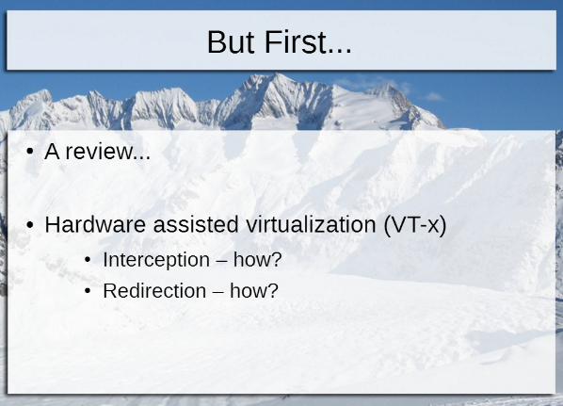We are starting Slide deck 9 now. He says it’s the most difficult of the entire class.

Two tenants of virtualization are interception and redirection. We understand interception, but how would you do redirection? Redirection is to an emulator function, or somewhere else.

How do these responsibilities compare to the memory management responsibilities of an OS? It’s similar. A guest OS VM will create its own page tables, because it thinks it’s in charge of all hardware. CR3 points to the page table. If you have direct control over CR3, 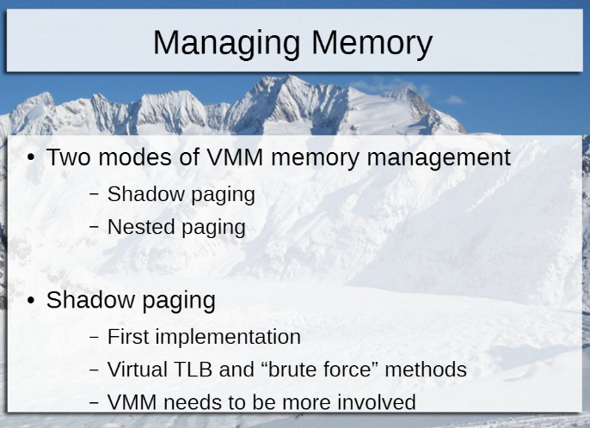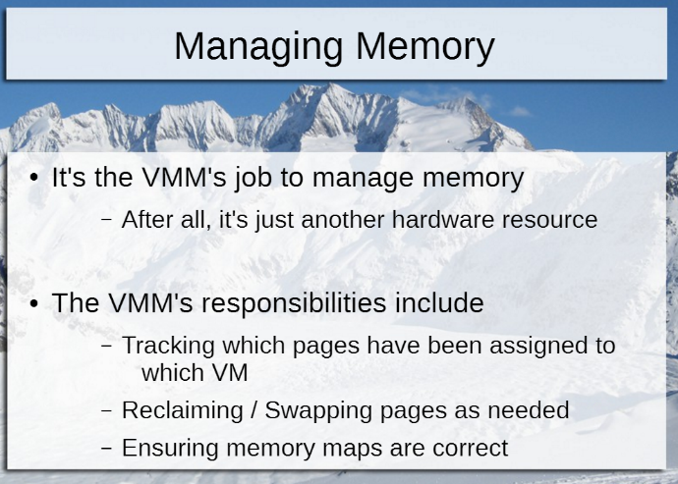then you have direct control over all of memory.

How can the hypervisor ensure that the physical memory used by each guest OS’s page table is in the memory area allocated to that guest OS?

1. 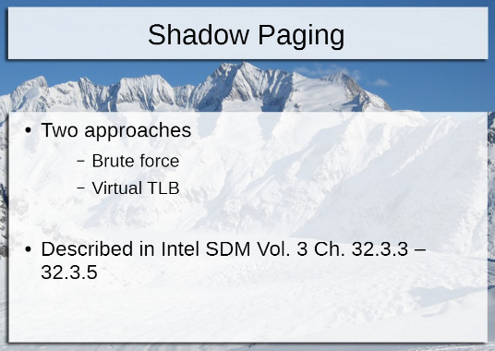Brute force approach – trap every single memory access to make sure it’s in the memory area allocated to that guest OS. Invalidate the mappings, and recompute the mapping each time. Intercept and fake everything. Huge overhead, so it’s not done.
2. Shadow paging (virtual TLB modeling) – create a secondary set of paging tables for the hypervisor to translate each guest OS’s page tables into “real” ones. We watch to see where CR3 is being set to. Each guest OS will have a bunch of processes running in it, and it’ll change CR3 when it changes processes. Each process has a page table. If we exit upon MOV CR3, then the exit handler will be provided with the place that the guest OS wants to use as the output of its paging table.
3. 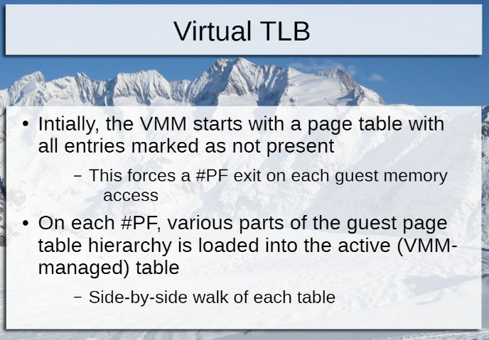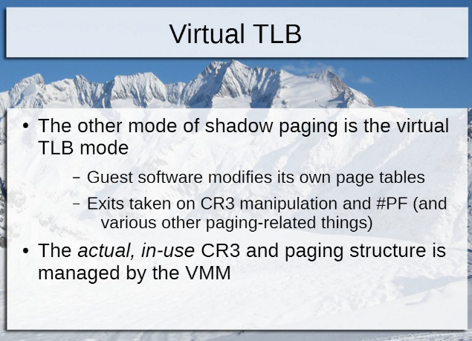Nested paging

What instruction changes the output of a paging table? It’s just a MOV. There usually isn’t an exit on MOVs. So, the hypervisor can’t tell whether the output of the paging table is still within the correct range.

The hypervisor could point CR3 to an empty page table (private shadow copy), which would cause a page fault when it’s attempted to be read. So, we also exit on page faults. When a page fault occurs, write that desired address into the shadow page fault. Then the failing address is re-executed, which results in a TLB load. No further access to the table is needed until this entry is flushed. That way, we can build up slowly over time the desired mappings. Plus, we can verify whether or not the page mapping was changed.

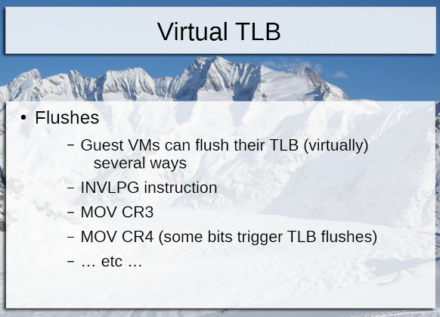Whenever a mapping is changed in the page table, there’s a TLB flush. Every time there’s a TLB flush, take an exit also. And an invalid page exit. So, now the hypervisor has full control of the guest OS memory.

If physical memory was pointing to someplace bad, it’s undefined behavior. In the hypervisor, if a guest OS wants to do it, terminate the VM.

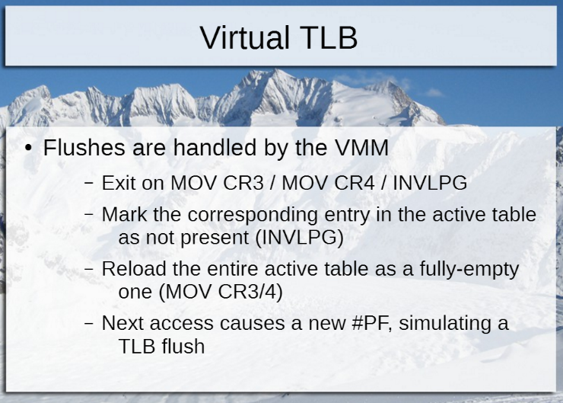When the guest OS wants to change the mapping, let it, and then when a TLB flush occurs, enter the new mapping into my shadow page table.

Method 2 is more efficient. You take exits on every context switch, every new page that’s accessed since the last context switch, and every time the TLB is flushed.

This works on every processor, but it is complicated and can break if you don’t do it correctly.

You also need to exit on read CR3, to give it the original value that the OS thinks it wrote to CR3.

The number of page tables in memory is equal to the number of processes that are capable of being run.

The number of shadow page tables is equal to the number of running processors.

Every time the guest OS does a context switch, you wipe out your shadow and make a new one.

If a guest OS gets 1 gig (from 1 gig to 2 gig), then the memory addresses will be 0 + 1 gig to 1 gig + 1 gig.

The role of a hypervisor managing VMs is similar to the way an OS manages processes.

How did the OS prevent a process from mismanaging its memory? Because it takes privileged access to change CR3.

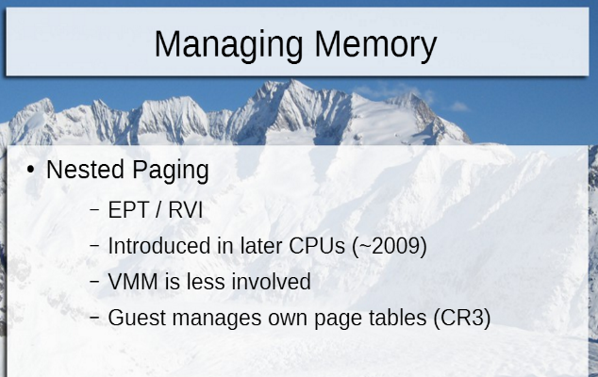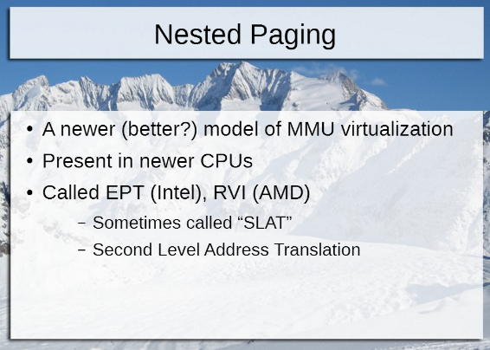Option 3 Nested paging (EPT / RVI / SLAT) is easier to implement. The initials stand for Extended Page Table and Rapid virtualization indexing and Second-level Addressing Tables. Core I# CPUs have this.

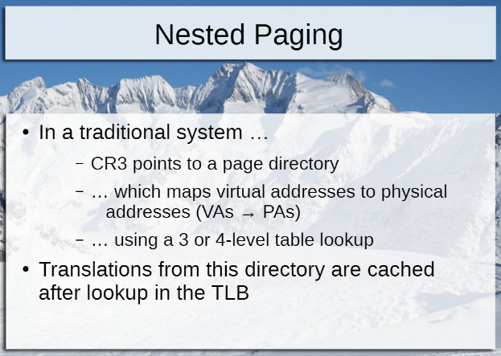Why would some newer processors not have this feature? Intel can charge more if it has more features. So, they can offer these same chips at cheaper prices if the feature is turned off.

Windows 8 client hyperV (built into windows) requires Nested Paging. The exact same code, when running on a server version of Windows, doesn’t require this feature.

Both options 2 and 3 are shown in the SDM.

Virtual TLB mode

With Virtual TLB, you create a new empty page table, and entries are eventually copied. Every time you walk the page table, you get a TLB mapping.

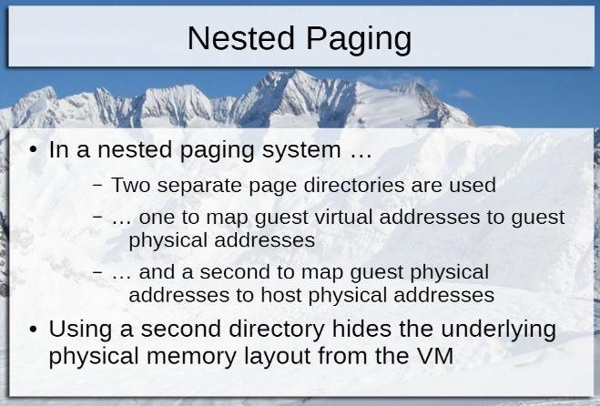SDM chapter 3.

Nested Paging (extended paging) sticks another page table between the guest OS and the VM manager (hypervisor). You use the CR3 + the EPTP (EPT pointer). You control the EPT pointer, which points to your new layer page table.

The guest OS’s page table maps guest virtual addresses to guest physical addresses. The second layer table maps guest physical to host physical addresses.

If you want to optimize a hypervisor, reduce the number of exits and shorten the time on exit.

The shadow page tables were taking a long time processor-wise. Nested paging is no more CR3 exits, no more flush exits, etc.

What’s the drawback for nested paging? Lot of translations. Every memory access requires possibly four more levels of the nested page table. And twice as many TLBs, so the TLBs are half as efficient.

But nested paging is easier to implement, but it has more memory traffic and TLB traffic.

There’s one new layer page table per VMCS. If there’s no mapping in the new layer page table, it’ll generate an EPT and kill the guest OS.

The big O would not be N*2. It’s N*N, because it’s not just two page tables, it’s going through two page tables for EACH access.

Another innovation: The TLB is now bigger, with a tag for each entry. The tag and VPID tells which virtual processor identifier that entry belongs to. VPID (Intel) = ASID (AMD)

Intel and AMD are supporting Nested Paging now, and not shadow paging. What’s a reason you would choose shadow paging? If you wanted the widest amount of compatibility with processors out there.

Now, read SDM Chapter 32.1 and 32.3.

A/D bits are Accessed and Dirty. Mark a 1 for the Accessed bit. Place an X where it says A___ (accessed) and D____ (dirty).

7020: Mov 0x1618, %rax means move the contents of 1618 and put it into RAX.

Compute the GVA for 7020 to GPA. Then to the HPA.

When you do writes, you dirty it. When you do reads, you access it.

Test %edi (%rax) is to interpret rax as an address, and test it against EDI.

XORing with 0x0 would just unmodify it and write the same thing back into its memory address.

Quiz 2 due Friday before midnight.

No page faults and no protection violations. This was a 10-minute quiz question from last semester.

X1010 is a guest virtual address.

Move the contents of 0x1080 into RAX.

The bonus homework is posted. It is due one month from now, on December 14. It’s similar to last year’s but it’s organized slightly differently. Extend KVM and add functionality to gather statistics on how it’s operating. 20 points are available.

You can work in groups of two. If you know people in Monday’s group, that’s fine.

The code is in the kernel source tree. Add some stuff into it and rebuild it. So when you launch VMs, they can take advantage of the new functionality. Launch a VM to exercise the functionality you add.

1. Add statistics counters for example the total number of exits for each type for all CPUs that KVM handles. The number of CPUID exits for all CPUs, the number of INs exits for all CPUs, the number of NMI exits for all CPUs, etc.

If HLT exits is zero, still print it. Last year, it was about 43 or 44 types that the KVM handles. The maximum would be around 60-something.

Give the user a command to output this statistic. He doesn’t care, as long as it works. It could parse a log. It could use /proc or /sys. It could be an IO control, etc.

Same with the other three commands. See it when it’s requested.

1. The total number of events injected per CPU. CPU0: 787 events, CPU1: 48402 events, CPU2: 9249 events, etc.
2. The average number of exits per second, per CPU. They start at zero when the system starts. It’ll have a similar output as # 2.
3. The average latency to process each exit in cycles, per exit type, per CPU. This is a 2-dimensional output, with types across the top in columns, and the CPUs as rows. The number of cycles will be the number intersection.

Keep numbers in the kernel, and then dump it on request either to a log, or kprint, or to the console, etc.

This is not a huge amount of coding, a few hundred lines. 95% will be getting the environment set up and figuring out where to put the info.

KVM needs a processor with hardware-assisted virtualization.

One thing that has worked for many students is to put this entire thing into another VM, running in VMWare fusion, virtualBox, etc. If you do that, your actual CPU must support nested virtualization (not nested paging, which is different). The CPU will need to offer hardware virtualization. This option is good for people with Windows machines.

** My home laptop is an Intel Core i7-2670QM CPU, which runs at 2.2 GHz. It’s running a 64-bit Windows 7 operating system with 8 gigs of RAM.

You can easily read up on how to rebuild a Linux kernel in an evening, and do sysfs nodes, etc.

He will answer questions, but not big ones. It’s an optional assignment.

Past semesters have been difficult to grade, because he had 130 to grade at once. So, that’s why he’s specifying a specific version of Ubuntu 16.04 LTS (long term support) to use. He will have an automated system that creates some VMs on your system and then run the commands on our environment.

Once you install 16.04, do all the updates, with apt-get update and apt-get upgrade.

Maybe next time he’ll have a git repo for us all to get it from.

Don’t do a kprint every time an exit is requested. You’ll get a billion lines of code.

You’ll run a KVM in your virtual machine that doesn’t do anything, because it needs a VM of its own. Then when you give it a VM of its own, it’ll generate exits on its own.

Turn in a code listing in either unified diff or git diff. He only wants the changes, not the whole tree. The diff command compares two trees and spits out the changes in a form which can be applied to a new tree, which is what he will do.

Diff –aNu

Git diff

One file will be the output, which contains the difference.

If it doesn’t build, doesn’t apply or etc. you don’t get points for that test.

It’s easy for you to verify this. Just build it on a new VM.

And answer the three questions.

You don’t have to do all the statistics. Each statistic is all or nothing. So the possible scores are 0, 5, 10, 15 or 20.

He has a good tool that compares code from the University of Michigan by analyzing syntax trees. He will feed them all in. Don’t rearrange lines, the tool will catch that. Some of the fails he handed out last semester were because of the bonus lab.

This assignment is suitably large that he shouldn’t see any duplicates.

Don’t sent zip, tar, rars, etc. Just a PDF of the answers and a text file with the diff in it.

You are adding data from across multiple CPUs. So you must lock it. This bit some students last year. Parts of the kernel is locked, because otherwise the kernel would crash. There are bunch of ways to lock code, with a lock before it and an unlock after it. Look for atomicity in the kernel, on Google. You can use the dumbest lock possible. That’s OK. It just has to work. The worst kind is possibly a spinlock. There are better ones. Atomic variables will work, with the appropriate get and set routines.

Don’t disable multiprocessor mode. That’s wrong.

There have been a few cases where his environment would be allergic to your diff. So, he’ll look at the answers and grade it manually in that case.

You might find that some of this might be in the source tree already. ☺

IO should have more cycles than CPUID, obviously.

Now we’re on Slide Deck 9 – Implementations

There are two techniques for accessing devices: IO and MMIO (MOV, OR, AND or XOR).

The BIOS assigns the regions for the devices. MMIO is faster than IO. IO involves bus locking and are slower. They can also only transfer 32 bits of data at a time.

What’s the largest MOV you can do to memory at a time? It’s not 64 (like %rax). Now there’s a way to write 512 bits of memory in one shot, with the multimedia extension instructions.

IO has a darker side, because you have to do device emulation.

IOMMU acts as an arbiter for the physical memory accesses that a device can access. The IOMMU sits between the devices and physical memory. It intercepts requests from devices and redirects them to other physical memory. It has a nested page table, which is owned by the hypervisor. It directs where the memory is directed, therefore.

QEMU code is much, much larger than a KVM. If you launch QEMU as a process, he has a CPU emulation module and a HW emulation module, which does device emulation. Most hypervisors will do CPU emulation through their KVM, so they’ll just use the HW emulation module.

QEMU and Bochs differ, because Bochs emulates every single instruction. QEMU will run at full speed and not do emulation until it needs to.

Let’s say you are creating the VMCS and set up the areas and do VMLaunch, and there’s an error, you might reboot spontaneously without knowing why. So, do it in Bochs. You can simulate it there and single step everything, including the VMlaunch step. It’ll tell you what’s wrong. A field is not set, or something is improper, etc. Both of the hypervisors he’s written, he used Bochs. Then, after the main loop works, transferred to real hardware (which is faster).

The machine independent parts are under /virt, and the machine dependent parts are under /arch/x/kvm.

QEMU app does what’s on slide 19.

Inside the QEMU app, you have threads inside for each VCPU. Normally, the OS schedules the threads for all the apps. The QEMU threads will cause KVM to do ioctrls. You don’t have to write a scheduler, just take advantage of the existing scheduler. It allows you to do memory balloons, etc.

Xen owns all the hardware.

DomU (meaning users) go through Dom0, which goes through Xen to the hardware. Dom 0 is the sysadmin console of the entire system. It’s older than KVM. It was built when we didn’t have hardware-assisted virtualization. You can run Xen on CPUs that can’t do exits. How? You have to do binary translation, emulation, etc.

There was a topic we skipped over, called paravirtualization. This is going away, because all CPUs have hardware virtualization now.

Each DomU will run an OS inside of it, and the DomU will capture any “exits” and Xen will handle them. Windows can’t run on it, because Windows didn’t make their kernel available.

The OS that Dom0 runs doesn’t matter, because there are only a few commands in it that do management.

Slide 25 is running in ring 3, since there’s no ring 1 anymore.

Paravirtualized devices are faster and fewer exits, so that’s what you’ll see.

Windows can run on it with HVM mode. In Windows Device Manager, what would you see? You’ll see Xen PVdisk, Xen PVNIC, etc. It’s faster to give Xen devices.

Workstation VMWare fusion and player have been sunsetted. So, they aren’t going to send out updates to it anymore. It resembles KVM.

However, the VMWare server product looks like Xen’s model, where the VMs are running in ring 3.

You can get the free version of VirtualBox, although they’d like you to pay for it, of course.

Microsoft didn’t write their own until HyperV. Before that, they bought ConnectX, which ran emulated x86 on top of a Mac. They called this a PowerPC. Cool! Microsoft renamed PowerPC VirtualPC for Windows.

Windows 7 XP mode is a hypervisor inside Windows 7 that runs XP. This was implemented using VirtualPC.

HyperV started out being awful. Microsoft has good things recently (like container runtime). But hyperV was awful. Version 2 was way better. Version 3 was almost as good as VMWare DSX. Version 4 passed them. Now you can run your entire Windows as a VM and you’ll never know. Make it invisible. And the subsystem bugs won’t take down the entire machine, and the security part can be run in a separate VM. Etc. Microsoft owns the OS, whereas VMWare doesn’t.

HyperV is now permanently a part of Windows.

But HyperV can’t be nested, except the only thing that can be nested inside HyperV is HyperV itself.

The Task Manager will show virtual machine host, and you’ll see several of those executing.

Now we’re on slide deck 10 – Management and Deployment

IBM was the first company to do virtualization. They did timesharing, and wanted to give everyone their own machine on one machine simultaneously.

The first x86 virtualization was the 386 that had virtual-8086 mode. 386 had 32-bits and paging, and the 8086 had 16-bit real mode. You could run two DOS machines in it, but there was no memory protection. DESQview, Novell, etc. fixed that problem by adding memory protection. DESQView had the screen in four quarters, and you could switch between them with key sequences, and timeslice between them.

He defines server virtualization as server OS running in a datacenter.

Which commercial products provide the ability to run a server OS? HyperV, VMWare DSX, Xen, any of them could run Windows Server.

Slide 6 – why do customers buy certain ones? They are more reliable than others. The VMWare certified qualification process is extensive. Their motto is “we never crash.” VMware is a purple screen of death, which hardly ever happens. HyperV is a lot more stable now too. They’re running Azure on it.

Additional capabilities – ease of maintenance, load balancing, live migration, which will move a VM from one server to another quickly. Copy the image to another VM. Start it concurrently, copy memory and register state and device state, then switch over to it.

Since I’m controlling paging, I mark all the pages in the source VM as “not ready”, so I’ll know which ones got touched. Transfer the pages over the network to the destination VM. While I’m copying them, some pages will be changed. Then just copy the delta. Loop this several times until the changes get almost to zero.

Time how long this takes, to see what the speed of the network is. Once the time it takes to do a pass is less than 10 ms, pause the source. If you want to change this, you can change the window. But if it gets too small, it’ll never happen.

If the network is slow, and you do 10 passes or more, give up.

Then transfer the VMCSs, which are small. That transfers the state of the CPUs. Then transfer the device state (and interrupts).

Then you can’t transfer the hard disk contents, because that’s usually way too big. Put it on a shared storage location that can be accessed from both hosts.

One last thing is to tell the virtual switch is to change the destination of the IP address.

Then I can finally start the new destination VM.

OpenFlow is a way to handle the VSwitch.

Live migration is part of the hypervisor software.

Two constraints: Must have shared storage and a fast network.

SAN (Storage Area Network) is a product you can buy from a huge storage company. NAS is a small hard drive. SAN is much more reliable and bigger. The protocols are different as well. A NAS will have a file-sharing protocol operating on top of Ethernet. A SAN has a dedicated network fiber for itself, so you lose the overhead from two Ethernet OSI layers.

SSD Local disks are the fastest, cheapest and easiest to replace. But they have a problem. You can’t do live migration with it, because the local disk is physically attached to the source.

If you want to increase a SAN, you have to buy another one and aggregate it. Storage virtualization provides SAN aggregation.

Lecture on 11/22/16:

We’re going over some sample exams that are posted.

1. __True____ True or False? A CPU that provides nested paging capabilities also supports shadow  
   paging capabilities?  
   2. __False____ True or False? A CPU that provides shadow paging capabilities also supports nested paging capabilities?

3. __________ Which of the following are not types of VMX capability controls, as listed in the SDM?

A. Processor based controls  
B. Instruction based controls  
C. Entry controls  
D. Exit controls  
E. All of the above are types of capability control

No such thing as instruction-based control.

__________ Which of the following is an example of an exit type that can be controlled using pin-based controls?

1. External interrupt exiting  
   B.  Exit on CPUID instruction  
   C.  #PF (page fault)  
   D.  All of the above are pin-based exits  
   E.  None of the above are pin-based exits

Answer: External interrupt exiting.

Name the structure in memory where VCPU control information and register state is stored. VMCX.

CPUID instruction is what category of control? Anything with an instruction is a processor-based control. External interrupt exiting is a pin-based control. All the others are processor-based controls.

For each of the instructions, is an exit possible for any reason? If it is, what is the exit that is possible and why?

Answer: Look through theh instructions and see which ones deal with memory. Those would exit because of permissions and priviledges.

Push %rbp could cause an exit, because it pushes rbp onto the stack, which is in memory. It could ca, use an exit if it’s not writable, etc. Intel wraps the stack around, so it’s never full. It could also cause a GP if the stack points outside of accessible memory and you’ve enabled page fault exiting.

Mov one register into another one doesn’t involve memory.

Xor xeroes a register. That doesn’t involve memory.

Mov %rbx, -16(%rbp) – if rbp points somewhere that is wrong permissions, then there’s an exit.

Cpuid will cause an exit if that exit is enabled, which it always is.

Jne 370 <cpu_topology+0x50> jump if not equal should cause an exit, since it’s memory. But it’s always jumping to somewhere on the same page, so that’s an exception to the rule that memory accesses always cause exit. <cpu_topology> is the name of the current instruction.

What information is kept in the VMCS guest state area, and how is this accessed by the hypervisor? The VM’s general purpose registers. You access them with VMREAD and VMWRITE.

Describe the steps involved in handling a VMEXIT.

Consider the following configuration and assume page fault exit is not on. Describe what happens when a guest VM does this. Look up TLB, walk the page table, and that’s the address that is read, and the dirty and accessed flags are updated.

If an entry is not in the page table, you’d get a page fault. Since page fault exiting is not enabled, it’s given to the guest OS and it’ll handle it itself.

If it’s in the guest VM page table, but not the nested page table, then it’s a page fault once you get to the nested page table. This is an EPT violation, or a nested page violation. It’s up to the hypervisor to satisfy that request.

What changes if you enable page fault exiting? For each of those, the hypervisor gets control first and handles it.

Under what circumstances is it dangerous to allow the guest VM direct access to each of the following devices? Which of these devices are not safe to allow direct access to. The ISA clock is not safe. The guest VM can stop it. Same with the Real Time Clock and the keyboard controller. If you have a good argument as to why it would be OK, he might be convinced.

Assuming you wanted to emulate a serial port (COM port) in your VMM, which is the best source of information you can look at in order to make the emulation successful?

COM port chip datasheet. The Intel SDM doesn’t talk about COM ports at all.

What scenarios are the IOMMU in VT-d configurations intended to guard against? How does having a IOMMU resolve these scenarios? IOMMU is used to pass through physical hardware into a guest VM and protect DMA. It has another page table that translates physical devices into memory.

Another sample test:

All virtualiation solutions consiste of two basic concepts: interception and redirection. How do these two items do these two things? How does this do interception and redirection?

1. Hypervisors using hardware-assisted virtualizaxtion with nested paging support.

Interception is noticing the resource is wanted and protect it. Take an exit when it is requested. Redirect it somewhere else. How would you redirect a request of the keyboard controller doing an OUT? As the hypervisor, I would package up that exit and pass it to QEMU, and let that emulate it for me.

1. Application virtualization solutions

We will answer that later in this lecture.

1. Describe how device I/O works in a virtual machine. Do memory-mapped I/O and I/O instructions (IN and OUT). Mention both of these. For eample, here’s how device I/O works for a clock. You turn on IO exiting. You do an exit and see what device it wants. Package it up to QMMU and let that emulate it and send it back to the VM.

In the other technique, mark all pages as not present, then when you get an IN or OUT, figure out what it wants to do, send it to the emulator and get an answer, and then send it back to the VM.

Now we are back on the Server Virtualization slides.

When we move virtual machines, you move registers, device state, disk image, etc. The disk image would be in a shared storage location accessible to both the source and the destination. SAN is Storage Area Network, which is the most expensive, but the most reliable and most enterprise-ready. NAS is less expensive. Anyone can put those together in an evening. Local disks are the cheapest.

If your SAN fills up, you’ll have a layer that fits there, and you can plug another SAN into it. You can do this with NAS too.

What workloads work well? What apps?

If you have dedicated hardware, it doesn’t work as well on a virtual server, such as a GPU – Graphics Processing Unit. But that works fairly cleanly nowdays too.

Desktop Virtualization is running a desktop OS in a VM somewhere, so all your employees don’t need laptops. You don’t need to buy expensive computers for everyone. You don’t have to worry about hardware or software maintenance or backups that way.

But there is a drawback. You must always have good network connectivity. Now the OS requires more graphics, so needs more network bandwidth. A good resolution nowdays is 1080p, vertically, and 1920 horizontally, and 60 frames per second, multiplied by true color (4 bits). This is 497 megabytes per second, which is 1080p bandwidth. We have about 30 megabytes per second bandwidht, typically. So, most network companies do compression and play tricks with the video, etc. It would only render whatever is moving. Another trick is they’ll render your font locally, and then send it in batch to the server.

Also, you can’t predict what the server workload requirement will be for a new employee. So it’s hard to do really good planning. You could serve more desktops if they don’t need a lot of bandwidth, such as receptionists and secretaries. Traders need fast bandwidth.

Server-side virtualization is done by VMWare, HyperV, Citrix, Zenserver, etc.

You also might have to deal with user revolt. Users don’t like not having smart laptops.

Skip type 3. No one does that anymore. The teacher doesn’t care about workspace virtualization.

Type 1 doesn’t have a host OS. Type 2 is loaded on another OS.

Which is bigger? The device emulation code is bigger than the hypervisor code. And the device emulation code is where more of the bugs appear.

There’s a security vulnerability that appears in Xen, which is used heavily by Amazon. It’s in the exit path that handles MMIO, any access of memory that is in the device region. If you extend a 32-bit address to a 64-bit one, then the VM could access memory outside their region. This was kept secret until Amazon and other companies had a chance to patch themselves.

HA DR BC means high availability, disaster recovery, business continuity.

We’ve been concentrating on a hypervisor that isolates the hardware from everything else. (This allows one piece of hardware to look like multiple hardwares, so you can run multiple VMs on top of it. This protects hardware, specifically memory, CPU, registers and devices. This blocked or intercepted requests from above and redirected them somewhere else.) You give each VM a copy of the keyboard controller, for instance.

But nowe’re going to talk about a hypervisor that isolates the OS and hardware from the rest above it. This makes one OS look like multiple Oss, so that multiple apps could run on multiple Oss. This protects your one OS license. This will intercept requests from apps to the OS from above and redirect them. This is a container runtime.

If you allowed two apps to access OS, they could break each other because they’d write over each others files, like config files, user data, libraries. DLL hell. Windows has a horrible problem of allowing apps to overwrite OS libraries. What if an app required an older version of the same library, which is now gone? You can give a different library to app1 and app2. This is application virtualization. You give each copy of the library to each different app, including bitmaps, files, etc.

With Unix, everything is modeled as a file, including drivers. But not with Windows. Windows also has a registry. It’s a configuration mechanism, storing configurations without writing to a file. Some people want to get rid of it.

What would be an example of an app that would want to modify an OS resource? Why did application virtualization come about on Windows? IE6 was always broken for everyone. It came with XP. For 10+ years, we were stuck with IE6. When new versions of Windows came out, new versions of IE also came. The apps written for IE6 slowly stated to not work. Some were business-critical, insurance, payroll, compliance, etc. One solution was an XP virtual machine, which is Windows 7 XP mode. Microsoft didn’t want to maintain XP forever.

So, Microsoft bought a company that did Application Virtualization, putting IE6 in a box. IE is built so deeply into the operating system that you can’t separate it out of Windows. When you installed IE6 on a newer OS, it would corrupt the newer versions of Windows. This new box it was placed in would intercept all requests for the OS and keep it all in the container, the application sandbox. Eventually, you’d keep a log and inventory of what all IE6 wanted to change, and only change it within its box, and not in the rest of the computer, so the rest of the apps would still work, for example DLLs.

Applications = processes in this case. This separates the OS from the process.

You can put multiple apps in their own container, so their changes are visible to each other but not to the rest of the machine, such as Microsoft Office.

Cut and paste is a OS resource, the clipboard. You can have a different cut and paste environment in the container than in the rest of the OS.

You don’t usually put two VMs in one box, but in Application Virtualization, you often do that.

Intercept system calls. There are 330 system calls. Open, close, read, write, delete, chmod, chown, move, etc. (There are actually a lot more, up to 4000, used for drawing graphics, which is no longer in user mode.)

When an OS resource is requested, keep a local copy inside its container. This is the list or manifest of DLL files inside its container. If it exists in the local container, get it from the cache, its own folder. The app is oblivious that anything has happened underneath.

If it’s not in the cache, give it a copy from the underlying OS, and it can write to the copy. But if the app is only going to read it, go ahead and pass it through.

What happens if the app wants to delete bar.dll? It’s not in the inventory, maintain a separate deleted list, or add a column to your inventory to say it’s been “deleted” and return file not found.

You would need to intercept all file requests. How about when an app installs a user account into the system? You usually don’t want app2 to see app1’s users.

The industry has decided that each app will be able to access the system’s time, and set it. ☹ Unlike a VM, where the system clock is off limits.

If you have two apps vying for the same socket, the first one will win. In his product, he had a virtualized separate TCP stack for each contianer. This way, he could ping one to the other without leaving the computer. ☺

Software device drivers – what type of app needs priviledge? VPN requires the network stack, which only priviledged apps can do. Some application virtualization products virtualize device drivers, and others don’t.

Create New Process is something you need to redirect.

You shouldn’t allow an app to reboot the machine. But most of the products out there allow you to reboot! Weird.

ITunes is a music store and player and talk to your iphone. Itunes have four drivers in ring 0, which are capable of doing anything. One for the ipod. One for Bonjour, a network discovery protocol for AppleTV. One for burning CDs, and he doesn’t remember what the fourth one is for. Any of those, if written maliciously, could see anything on the machine.

What are your goals? To support old versions of apps, or multiple versions of apps at the same time.

Can you copy c:\app1\ to another machine, including the inventory and run it on another machine with the same underlying OS, you’ve moved the app! Ease of provisioning and maintenance!

This is what Docker does. It’s one command to install something. Just copies the data onto another machine and execute it.

What does the inventory start with? It starts empty, and accumulate over time. Things never get removed. But they get modified and altered.

Named pipes and kernel objects would be protected also, since they’re in the OS.

Four problems with moving VMs: network speed, network switch to point to the new place, shared storage and make sure the underlying hardware is close to being the same. Normally you can’t migrate from an Intel hardware to an AMD or vice versa. Have your hypervisor turn off any CPU capabilities that aren’t available somewhere else.

Syscall doesn’t take any arguments! It will always go to the same location in the OS kernel, the syscall target function. It looks at %rax to see which function to call.

Where would you intercept the open command? At the syscall entry, exit, at the library level, or at the actual implementation in the kernel? Best place is in the library, but it’s more robust to put it in the kernel. You used to be able to hook into the kernel and do what you needed. But now Microsoft has shut that off, and you’ll get a blue screen. AppV from Microsoft does kernel access, though.

Unlink is delete.

Namespace virtualization will change the name of the resource, like append /app1/ at the beginning of it. This is their way of interception.

Noone does process injection anymore.

You could run VMs on top of VMs, etc.

There are no products that do device drivers perfectly. Their product was pretty close, only 99%. You’d need to turn yourself into a VM.

There’s a quiz that’s due on Tuesday 11/29.

Lecture for 12/6/16:

There’s a new quiz due 12/13.

…So you walk this page table.

The a bit is access, D means dirty and you wrote to it. P means present, and the translation is valid. The first thing when looking up 3028 is to go to x3000, which would give you a page fault. VMM = hypervisor. EPT is the same thing as a page fault, but it occurs in the nested page table.

This is question # 3 on a sample test, which he posted. I also need to post the slides here into these notes.

Who does the page fault, the VMM or the guest OS? You do not have page fault exiting turned on, so it won’t go to the VMM. It’ll be the guest OS handling it.

Another version of the exam says P only in 0x3000. Write an A, and then go to the nested page table. 3000 is translated into 12000, which is also present, and the permissions are RW. So, it would be a straight read.

But what if there was a P in the Guest VM page table, and nothing in the nested page table. So you’d get an EPT violation.

1. What would happen if external interrupt exiting was disabled on a VCPU and an external interrupt was received by the PCPU? What is an external interrupt? Real hardware. Tons per second, especially from the clock. It doesn’t matter what code you are running.
2. Still this question. If you’re running guest VM code, it’ll go to the guest’s clock handler, since exiting is turned off. If you are running hypervisor code, it’ll go to the VMM’s clock handler. But before doing either one, it will check to see if it’s masked (disabled). It’s disabled when you are in an interrupt handler, for example. So the answer is C: nothing will happen if the interrupt is masked.
3. Which of the following statements regarding IOMMUs is true? You don’t need to have an IOMMU to totally emulate a disk controller. QEMU emulates everything in software, so you don’t need an IOMMU. Is an IOMMU used to enforce memory isolation when DMA is used with certain devices? Yes. B is the definition. C is not true because keyboard is a port=based IO, and IOMMUs don’t help you with port-based devices.
4. Which of the following statements about namespace virtualization is most accurate?

Namespace virtualization means altering the name or path of an intercepted resource.

1. T or F. All CPUs that support VT-x support VT-d (the IOMMU stuff)? No. VT-D is a specialty feature that is only in more expensive processors, not in all. You can still make a hypervisor siwh VT-X, but we can’t do device passthrough, because it can’t be done safely without VT-D.
2. What techniques can a hypervisor author employ to reduce TLB pressure when shadow paging is in use? Shadow paging is virtual TLB. Use ASIDs and VPIDs, which are with nested paging. What governs the number of TLB entries consumed by a hypervisor? The TLB is really big when you touch a lot of pages. So how do you touch fewer pages? Increase the page size. Place your code that always gets executed on the same page, with compiler and linker tricks. If you were using nested paging rather than shadow paging, you can use larger pages in your hypervisor, in your nested page table. With shadow paging, your additional pages would have to match the original TLB. But not with nested paging. Also, make sure you aren’t doing a lot of flushing. Another good answer is to choose a VMCS to execute based on how much TLB flushing it would cause, regardless of its priority.
3. What techniques should operating system authors use to improve performance when their Oss are used in virtualized environments? He won’t answer this in class.

Another question: Place the following activities that occur during VM live migration into order, from earliest to latest. Some activities may not be used, and some may be used more than once.

System Admin configures shared storage for VMs. Then migration is paused, final pages are trasnferred. Then VMCS content is transferred. Then device context is transferred, and lastly, delete the original VMCS from the original machine.

If you have a multiprocessor VM being migrated, how does that change it? You’d have to transfer a VMCS for each CPU. And delete multiple VMCSs from the original machine.

Back to the slides.

Which operations need to be intercepted with application virtualization? Anything with a name. The name of a file is a string. You can prepend a directory name into a string. This is namespace virtualization.

We are giving an app a private view of the OS, so it doesn’t comflict with another app. Each app (especailly browsers) will listen on port 80. But you can’t have two apps listening on the same port. How do you virtualize a port? Change the name of the port. But you can’t.

So, assign 20080 to one app and 21080 to another. And do another redirection for all input streams on 80, redirect them to 20080 or 21080, depending on the app.

That’s how you do namepsace virtualizatsion of ports.

How about user accounts? When a container requests a user in Linux, it normally goes to /etc/passwd. Typical products will add 1.4 million to the beginning of the user ID number in /etc/passwd.

Describe the steps you would use to determine if a given workload is better for nested paging or shadow paging? He gives us two hypervisors to choose between. You can’t test it on both. Analyze how it uses pages. Which workloads work better on shadow paging? If you have a small set of pages and it doesn’t do any other translations, shadow paging is better. But if everything fit in the TLB, they would both run the same.

System calls are when you request the OS to do something on your behalf. If it’s in your file inventory, you’ve modified it, and you get it from there (the cache). If it’s not there, and it’s a read operation, progress down a layer and read it. If you don’t find it in any layer, return “file not found.”

If you are doing a write, copy it from the next lower level, and then modify the copy. If you’re doing a delete, make a sentry file or a white-out file, or a tombstone file. These are all names for the same thing, the list of files that are “deleted.”

O_CREAT means open or create, whichever is applicable. Create file if it doesn’t exist.

Windows’ Create File can be used for opens or creates. When you create or open a file, you specify the rights for that file. Some systems will allow you to create a file handle with read, and then promote it to write.

With windows, all systems software asks for all permissions, specifically generic all. But this is not good. You should wait until you actually need to change the file before you copy it into your container.

If you change the permissions, where should the permission changes be reflected? How about change owner? Are those writes? You could try to remember it in the inventory, but then the inventory will get very big! You don’t need the entire contents of the file if you are just changing the owner. In the professor’s product, every time a simple metadata change was made, create a 0-byte copy in the container. Copy the contents only if you need the contents.

How do you hook a system call, so you can intercept it? The traditional way is through an INT $0x80, but this is expensive. So the preferred way is now through the SYSCALL instruction, and its little brother is SYSENTER for 32-bit calls. The pointer to where it’s supposed to go is in the model specific register once it gets to ring 0. There are many places you could intercept execution.

Let’s assume we change it at the syscall table location. It’ll go to OUR open code instead. We just append to the path at the beginning of the filename, and then call the original syscall open function.

You will now have just changed the open function for the entire system. But you should only change it for that particular virtual container. So, keep track of your process IDs. This adds a lot of overhead.

But this is also how malware works, so antivirus products are watching this table. ☹

This is a protected structure with Windows, so it will blue screen the machine if it detects tampering with this table. It’ll also erase all the stacks and memory. The blue screen will be called “critical structure corruption.”

This table is checked at random intervals with Windows. This table checking code is scattered throughout the Windows code at thousands of places.

So, instead of modifying the table, you could change the model specific register, or in the libc library used by the application in ring 3.

64-bit Windows upgrades especially blue-screened the machine if you messed with this table. So, they’ve come out with a new way, which we won’t get into now.

When you fork a process, the parent process will have access to the memory for Process 2. P2 will be paused until exec is executed.

VMware’s Thinapp does this, by modifying the child process and then executing it.

When an app installs something in the OS, like drivers, it will have to run at ring 0, so it’s hard to keep track of them.

Games do this a lot, for anticheat technologies.

Windows philosophy is that if you can’t use the APIs, go around them and do whatever you need. Get to ring 0.

Once we do so much virtualization in the OS, might as well be a hypervisor. He spent 2004 to 2010 doing this!

The final is 5:15 to 7:30, open book, open notes, no electronic devices. He will print out the SDM pages for instructions.

No class for next Tuesday. But come next Monday at 6 pm for the final review class. Next Tuesday is the dead day, the day between instructions and the first finals day.

Final review:

Starting on deck 7.

With Virtual TLB, the guest OS manages its own page tables, but you do an exit on the CR3 manipulation, see the slides. There's only one TLB.

What are a benefit of shadow paging? Supports all processors.

For nested paging and shadow paging, see the SDM document chapter entitled protecting memory addressing.

Nested paging takes 1/10th the complicated code. Also, processor vendors are working on improving nested paging, not shadow paging.

INVLPG pages a single page out of the TLB. MV CR3 flushes the whole TLB, with a few global page exceptions.

The difference between MOV CR3 and MOV CR4 is that CR4 MOV will also flush the global pages too.

SDM vol 3 chapters 32.3.

Nested = SLAT.

The guest OS page table from Guest virtual to guest physical addresses. The Extended Page Table (managed by the VMM), translates from guest physical to host physical addresses.

Intel just announced they are moving to a five-level paging table for 64-bit machines. Some customers of theirs are bumping up against the maximum memory. They’re increasing to 57 bits!

Potential drawback of nested paging is overhead, twice as many TLB entries. Every time you access a page table or TLB entry, it’s a memory access!

Can we make more efficient use of the TLB? Yes. We can use VPIDs or ASIDs (tags). What is this entry for? The hypervisor, a VMCS, which process. You only need to flush entries with your VPID.

Nested and shadow paging are both about protecting access to memory.

How does nested paging work? He might ask us what happens with nested paging when a certain instruction is executed.

Now he switches over to the Devices slides.

The reason we talk about devices after memory is because devices access memory.

Two approaches are IO ports and MMIO.

What type of instructions are used for doing IO to IO ports? IN and OUT, and their relatives. They are good for low bandwidth devices. They lock the bus and cause everything else to stop. They are limited to 32 bits at a time, only. Use it for the real-time clock and the interrupt controller, which just sends a number command.

The second way is MMIO. It’s much faster. Which instruction does MMIO use? MOV. You can also OR, AND, INC, ADD, SUB, etc. which also touch memory. These all use MMIO. How much data can you move in a single MMIO instruction? 512 bits. MMIO touches memory all the time. OUT does not write into memory. They use port numbers which skip memory and write directly to a port.

How do you capture exits for Ins and OUTs? Turn on unconditional IO exiting or bitmap-based exiting. Bitmap-based exiting means for certain ports only. Ports go from 0-FFFF, but only a few ports are actually used. Mark a 1 in the FFFF-sized table for the ports you want to exit on those.

Some Oss will read all ports to see what hardware is connected upon bootup. Someone may need to run legacy software that does this on your VM. So, use bitmapping instead.

MMIO is the second way. Each device gets one or more memory regions assigned to it when the system starts up. What assigns these regions? The BIOS. The OS is free to reassign the regions, but this is hardly ever done.

So, if someone does a MOV to a region that’s assigned to a device, what happens? It depends on the hardware and the driver manufacturer.

There are only a few devices you MUST have. Not PCI, SATA, audio controller, etc. They are all optional. The required ones are console, storage, legacy devices and network. Which of these are a candidate for using MMIO? Network because you are dealing with lots of data. Also storage.

When would console be a MMIO device? When it’s graphical, dense.

If your hypervisor provides an emulated sound card, how could you tell when it’s being written to? Mark it as not there, then it’ll generate a page fault, and do an exit on page fault. Emulate the memory range assignment.

When you write a hypervisor, you will provide a BIOS for it, which will carve up memory regions.

What are you given with an IN or OUT instruction? Port #, size of the IO (8, 16 or 32), data, and direction (IN or OUT).

You are not a device driver, you are the actual device. You are writing the other side of the driver.

QEMU is what many hypervisors use as their device emulation layer. It’s much bigger than the core hypervisor itself, and it has a wide variety of pieces of hardware it can emulate for you.

Device Passthrough. What do you need to do device passthrough safely? This improves performance. The IO exits take the longest to process of all the hypervisor exits.

What could a malicious guest OS do if given direct access to a NIC? It could access pages of memory it doesn’t own. A NIC is directly attached to the system bus. The VM could program the card (via reads and writes), to place packets into certain places in memory, which is a system area. That area has no oversight from the NIC. This is malicious DMA.

IOMMU protects against this. It’s a page table that sits between devices and memory. This is implemented in a standard called VT-D. It allows the hypervisor to safely constrain where the card can write to. If a system administrator asks for device passthrough, what should you do? Say no and refuse to boot. This would go around all security in your hypervisor.

Do all CPUs that have VTX also have VT-D? No. This is because of this.

IOMMU can be used with both shadow and nested paging.

Read “intel virtualization…..” paper, chapters 1 and 2.

Now he’s opening slide deck 9 Implementations.

He skipped through the first half of this deck, up till QEMU. QEMU is much bigger than a core hypervisor.

You have QEMU processes that talk to the KVM processes, and ask it to control a device, for example control this virtual CPU in the VMCS. If you need to write to the disk, send the signal back to QEMU to handle. The QEMU is doing device interrupts, dispatches, etc. for the kernel.

What type of hypervisor is this? This is type 2, meaning an operating system that can run processes that aren’t virtual, and you can add in QEMU and KVM modules. Anything that has a true OS on its core is type 2.

Compared with Xen, which is built differently. The Xen hypervisor code is running with Dom0. Dom0 manages other DomUs. These are user domains. Dom0 manages access to the hardware, via hardware emulation. Or you could run the DomUs in user privilege mode.

Amazon uses Xen. They’re the largest cloud provider. Google is using a specially-modified version of KVM. Google’s is faster, but that might be due to better hardware.

Use Xen or KVM? It all depends on the workloads you are running, and optimizations the guest OS is doing. Perhaps you can skip some steps if you know what you are running on.

Both would be fine. It all depends on price or performance.

Paravirtualization won’t be on the exam.

VMWare’s workstation resembles KVM. The server product resembles Xen.

He may ask us to give him a type 1 architecture, which is where it runs directly, Xen or OS2.

Type 2 would be KVM, parallel, virtualBox, VMWare Fusion player and workstation.

HyperV from Microsoft started as a joke. It’s very good now, though. Azure hypervisor is based on HyperV.

VMWare now makes money selling the things on top of Fusion, like memory management, knowledge, etc.

Now slide deck 10. Now a lot in this deck.

Why do virtualization? Reduce power and head and improve economies of scale by taking advantage of under-utilized machines. Adds in the ability to do load balancing, live migration, etc. Why would you pay for live migration? Less downtime. You can migrate VMs to another host, do maintenance on the hardware and then move the VMs back. Disaster continuity, disaster recovery, etc.

First thing is to spin up new blank VMs on the destination, then copy the contents of VMs from the source to the destination. Mark all pages offline, so you can get a list of all pages that have been touched. Reiterate over the pages until the list of active pages are smaller than the window 10 ms. Then pause the VM, copy the last few pages, copy the VMCS (registers), and then spin it up, and point to the new one. Point to the shared storage and tear down the original VM.

Slide 16 describes type 1 or type 2.

Don’t worry about workstation virtualization for the final exam.

Now on to slide deck for week 15 (deck 11), covering Application Virtualization.

Interception and redirection. With App virtualization, intercept system calls. Redirection means supplying a different resource than the one requested. A resource could be a file or a user or network stack, process IDs, process names, etc.

When you intercept an OPEN request, you have the filename and directory. Prepend a new directory to it. This is called namespace virtualization. Just modify the string.

You could also modify a userID, which is an Int. Add a big number to the int. You could also modify a port number by adding a number to it.

Limitations of application virtualization? They are not as all-encompassing as a hypervisor. You can’t do some things. Some applications require ring 0, and you’ll need to be under all that code, which makes you a hypervisor pretty much.

What are some of the benefits to application virtualization?

Microsoft does the Linux Compatibility Layer by translating all the system calls from Windows to Linux on the back end. But there’s much more complication to it than that.

Then there was a slide deck on Container Technology, which will not be on Tuesday’s final exam. Only Monday’s.

Docker is an example of how LXC and cgroups are actually used. These are built into the kernel. They are subsystems that are controllable via command lines or APIs (more likely). LXC provides several default namespaces.

Containers are their own separate universe, with the apps inside them. Prevent them from seeing apps in other containers. LXC gives us the ability to virtualize the process ID namespace. Add a large number to each process ID.

Network namespace is segregated into IP address and port number. There will be a firewall directing traffic between different namespaces.

Why would you virtualize the hostname? Each container gets its own host. Localhost is within a container too. A hostname is a string.

IPC deals with shared memory, named pipes, etc. In the case of a container, each pipe would be unique to each container.

Some applications use userIDs, some use names, so we’ll need to handle both of these.

How do you handle the root ID? It’s user ID 0. How do you have root inside a container? They get mapped to nonconflicting userIDs on the host.

/htdocs is where your static web content is.

Mount namespace allows per container views of the filesystem, which are different than other containers.

Docker is a user of LXC, and uses APIs. You can use them manually with commands like xgexec, etc.

What’s the difference between AUFS and devicemapper? They both look through their layers to find the I/O or storage resources you need. When you find it, copy it to the top layer if you are writing to it, and write to the top layer copy. Both AUFS and devicemapper do this.

What’s the difference? With AUFS we copy the file to the top and read the file, but with devicemapper, it’s block-based, so you copy the blocks. It remembers which blocks have been written to. It copies only the active blocks to the topmost layer and uses that one. With AUFS, everything you have in the top layer will be whole. But with devicemapper, you’ll only have blocks at the top. AUFS was first. Ubuntu has it, but Red Hat doesn’t.

Docker gives us several plug-in choices. Anything that gives you a layered stack can be used. Docker provides other benefits too.

What does cgroups provide that LXC doesn’t provide?

The PNG theorem is in the first half of the class, and won’t be on the final.